**DESIGN, DEVELOPMENT AND ANALYSIS OF POSTURE MONITORING SYSTEM**

**ABDUL NIZAM** (21D202)

**KEFIRA JANE.J** (21D229)

**SAI SRI HARINE.C** (21D241)

**SARVESH RAJAVEL.R** (21D245)

**SYED ALTHAMISH UR RAHMAN** (21D250)

Dissertation submitted in partial fulfilment of the requirements for the degree of

**BACHELOR OF ENGINEERING**

#### Branch: BIOMEDICAL ENGINEERING

of Anna University



**October 2024**

**DEPARTMENT OF BIOMEDICAL ENGINEERING**

**PSG COLLEGE OF TECHNOLOGY**

**(Autonomous Institution)**

**COIMBATORE- 641 004**

**PSG COLLEGE OF TECHNOLOGY**

(Autonomous Institution)

**COIMBATORE-641 004**

**DESIGN, DEVELOPMENT AND ANALYSIS OF POSTURE MONITORING**

**SYSTEM**

Bonafide record of work done by

**ABDUL NIZAM** (21D202)

**KEFIRA JANE.J** (21D229)

**SAI SRI HARINE.C** (21D241)

**SARVESH RAJAVEL.R** (21D245)

**SYED ALTHAMISH UR RAHMAN** (21D250)

Dissertation submitted in partial fulfilment of the requirements for the degree of

**BACHELOR OF ENGINEERING**

#### Branch: BIOMEDICAL ENGINEERING

of Anna University

**October 2024**

**.....………………………… ………………..………………**

**Dr. Subhashini. N Dr. Vidhya Priya. R**

**Faculty guide Head of the Department**

Certified that the candidate was examined in the viva-voce examination held on …………………

**…………………………… ………………………..**

**(Internal Examiner) (External Examiner)**

**CONTENTS**

**ACKNOWLEDMENT……………………………………….………………………………………. V**

**SYNOPSIS………………………………………………………………………………..………….VI**

**CHAPTER 1…………………………………………………………………………………………..7**

**INTRODUCTION………………………………………………………………………………….7-15**

* 1. **Introduction……………………………………………………………………….7**
  2. **Postures……………………………………………………………………….8-14**
  3. **Problem Statement…………………………………………………………….14**
  4. **Objective………………………………………………………………………...14**
  5. **Novelty……………………………………………………………………….14-15**

**CHAPTER 2….……………………….………………….………………………………………….16**

**2.1 Literature review………………………………………………..…………...16-28**

**2.2 Market survey………………………………………………..…………………..28**

**2.3 Patent search…………………………………………………………………….28**

**CHAPTER 3…….…………………………….……………………….……………………………29**

**MATERIALS AND METHODOLOGY…………………………………………………….29-34**

**3.1 Materials and circuitry…………………………………………..….............29-30**

**3.2 System Architecture…………………………………………………………31-34**

**CHAPTER 4………………………………………….……………………………………………..35**

**DATA COLLECTION AND ANALYS……...……………………………………………………………………………….….35-48**

**4.1 Data Collection………………………………………………………….…....35-38**

**4.2 Data preprocessing…………………………………………………………..38-41**

**4.3 Feature selection and reduction…………………………………………..41-44**

**4.4 Training and testing………………………………………………………….44-48**

**CHAPTER 5………...…………………………………….……………………………………....…49**

**RESULTS AND DISCUSSION………………………………………………………………...49-53**

**5.1 Result……………………............................................................................................49-51**

**5.2 Limitations……………………………………………………………………….…………51-52**

**5.3 Future works……………………................................................................................52-53**

**5.4 Conclusion…………………………………………………………………………………….53**

**BIBILIOGRAPHY……………………………………………………………………………………...54-55**

**ACKNOWLEDGEMENT**

First and foremost, we are deeply grateful to PSG College of Technology, particularly our esteemed Principal, **Dr. Prakasan K**. The college's commitment to research, provided us with exceptional opportunity and necessary facilities to conduct this dissertation work. The stimulating environment fostered a love for academic exploration.

Within the Department of Biomedical Engineering, we extend our heartfelt thanks to **Dr. Vidhya Priya R**, Head of the Department, for her constant support and encouragement throughout our dissertation.

Our deepest gratitude goes to our esteemed project guide, **Dr. Subhashini N**, Assistant Professor (Sr. Gr), for her insightful and comprehensive feedback, and unwavering support which were instrumental in the successful completion of this dissertation. We are incredibly fortunate to have had a supervisor who so generously invested time and effort in our development and this project.

We would like to express our keen gratitude towards our tutor **Dr.Sangeetha M s,** Assistant Professor (SI.Gr.) and **Ms. Shrinithi. S** for their constant support and encouragement throughout our project phase.

We are grateful to **all the faculty members** of the Department of Biomedical Engineering for their incredible support and valuable insights throughout our study. Their dedication to teaching and mentorship has significantly enriched our academic experience.

Finally, we are privileged to thank the dedicated laboratory staff for their timely assistance and support, which played a vital role in facilitating our research endeavors.

This dissertation would not have been possible without the contributions of these individuals and institutions. We are truly grateful for their guidance, support, and encouragement.

V

**SYNOPSIS**

In contemporary society, posture-related musculoskeletal disorders are on the rise due to extended periods of sedentary behavior and repetitive tasks. People are increasingly spending most of their time slouching and hunching over desktop screens, tablets and mobile phones. This continuous behavior over extended periods of time causes severe upper and lower backpain that subsequently leads to cervical spondylosis and bulging of lumbar discs. To recognize the prevalence of this issue, the development a posture monitoring system manifested as a shoulder strap to monitor the siting posture of individuals by computing the angular tilt of shoulder and upper back and utilizing a pretrained machine learning algorithm to predict the current posture is proposed. Key challenges within the field, such as the accuracy of posture detection, user acceptance, and seamless integration into daily routines, are identified and resolved through automated timely calibration. These challenges that underscore the need for innovative solutions and interdisciplinary collaborations to overcome barriers hindering the widespread adoption of posture monitoring technologies have been considered during the development. By offering a comprehensive understanding of the current landscape, including challenges and emerging trends, this project serves as a roadmap for future research and development endeavors a robust, convenient and affordable posture monitoring system. Ultimately, the widespread adoption of our system holds the promise of reducing the incidence of posture-related disorders and enhancing musculoskeletal health across diverse environments such as workplaces, educational institutions, and healthcare facilities enabling the user to train and habituate better postural practices.

VI

**CHAPTER 1**

**INTRODUCTION**

* 1. **INTRODUCTION**

Sitting is one of the most common postures in daily life, with studies indicating that people spend around six hours sitting each day. Consequently, back pain has become a widespread and troubling issue, now ranking as the third most common reason for individuals to seek medical attention. Approximately 70-80% of those experiencing back pain attribute it to poor posture. Chronic back pain develops gradually due to sedentary behavior, often exacerbated by prolonged use of digital devices. This has resulted in 15-19% of people suffering from upper back pain and 60-70% from lower back pain.

The most frequent activity while sitting is using mobile phones, with an estimated 4.77 billion users worldwide as of 2017. This number was projected to increase to 5.07 billion by 2019. As more essential services are integrated into smartphones, and with the growing number of mobile applications, this has further promoted a sedentary lifestyle. Alarmingly, a recent study reveals that looking down at a phone is comparable to placing 60 pounds of pressure on the neck. Correspondingly, another study highlighted that a condition known as "Text Neck," caused by 60 pounds of neck pressure, can lead to Kyphosis. This disease is an excessive spine curve because of abnormal rounding of upper back. which can lead to breathing problems that may eventually require a surgical treatment. Chronic Low Back Pain (CLBP) is another significant cause of disability, affecting similar populations across various countries and cultures, with one in five adults experiencing CLBP each year. In industrialized nations, chronic pain is rapidly becoming the foremost health issue, contributing to annual low back pain costs of $100-$200 billion.

Acute back pain, which often results from injuries like muscle strains or ligament tears due to activities such as heavy lifting or sudden movements, can also lead to considerable discomfort and mobility limitations. Back pain significantly affects an individual’s quality of life, reducing productivity, limiting movement, and causing emotional distress. Studies have found that slouched or hunched posture not only reduces energy levels but also negatively impacts mental well-being, such as happiness and depression. Poor posture also affects workplace productivity, with approximately 75% to 85% of worker absenteeism being attributed to recurrent or chronic back pain.

Despite its prevalence, simple preventive measures can effectively mitigate these disorders. According to medical research, most cases of severe Kyphosis can be treated and prevented through exercises aimed at improving posture and maintaining a straight spine. A study by Robertson et al. found that musculoskeletal risk decreased after 16 months of ergonomic posture training for seated individuals. Further studies by Choobineh et al. and Menendez et al. demonstrated that ergonomic interventions could reduce musculoskeletal discomfort and related symptoms. Additionally, research by Taieb-Maimon et al. showed that posture risk diminished after three weeks of an experiment using a camera to display the seated individual’s sagittal posture. Therefore, maintaining proper spinal posture is possible and essential, which is the goal of our system’s design. Several systems have been developed to address this issue, comprising three main components: data collection, data analysis, and feedback. The system incorporates all these elements, with a particular focus on analyzing the collected data while in a seated position.

* 1. **POSTURES AND THEIR EFFECTS ON THE BODY**

The posture of the human body significantly affects not only how we look but also our long-term health. Whether sitting or standing, improper posture can strain the musculoskeletal system, leading to discomfort, chronic pain, and even structural damage over time. In this analysis, we explore five common postures — hunching, slouching, neutral, leaning right, and leaning left — along with their associated body angles and the potential short- and long-term health consequences.

**1.21 HUNCHING POSTURE**

**Definition and Common Causes:**

Hunching, or the forward rounding of the upper back and shoulders, is a posture often adopted when individuals spend prolonged periods sitting at desks, using smartphones, or engaging in activities that bring their eyes forward and down. This posture involves excessive curvature of the thoracic spine and forward head tilt.

**Body Angles:**

* **Head Position:** The head typically tilts forward by 30-45 degrees in a hunching posture.
* **Thoracic Spine:** The upper back may round to an exaggerated kyphosis beyond the normal 20-45 degree curvature of the thoracic spine.
* **Shoulders:** Shoulders tend to protract (round forward) by 20-40 degrees from their neutral alignment.

**Biomechanical Effects on the Body:**

1. **Increased Neck Strain:**
   * The further the head moves forward, the more strain it places on the neck muscles and vertebrae. For every inch that the head moves forward, an additional 10 pounds of pressure is exerted on the cervical spine.
   * This "text neck" phenomenon leads to persistent pain, reduced flexibility, and can contribute to long-term conditions such as cervical spondylosis and disc degeneration.
2. **Thoracic Hyperkyphosis:**
   * Hunching increases the natural kyphosis (forward curvature) of the thoracic spine, leading to hyperkyphosis. This spinal deformity places stress on the vertebrae, intervertebral discs, and surrounding ligaments, increasing the risk of mid-back pain and reduced mobility.
3. **Shoulder Impingement and Pain:**
   * As the shoulders round forward, the muscles in the chest (pectorals) tighten while the muscles in the upper back (rhomboids and trapezius) weaken. This muscle imbalance can lead to shoulder pain, rotator cuff problems, and limited shoulder mobility.
4. **Restricted Breathing Capacity:**
   * When the spine is hunched, the rib cage becomes compressed, which reduces lung capacity and limits oxygen intake. Over time, shallow breathing can lead to reduced energy levels and increased fatigue during physical activity.

**Long-Term Consequences:**

* Hunching can result in chronic upper back pain and tension headaches.
* This posture contributes to long-term musculoskeletal issues such as spinal deformities, decreased range of motion, and increased risk of developing conditions like scoliosis or herniated discs.
* The shortened chest muscles and overstretched back muscles make correcting this posture challenging without targeted exercise and therapy.

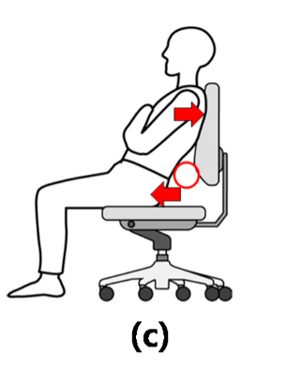

**FIGURE:1.1 HUNCHING POSTURE**

*(****Source****:https://www.semanticscholar.org/paper/A-Survey-on-sitting-posture-monitoring-systems-Tlili-Haddad/e9c884d951533963d4ae99109859ea03313f2a0d)*

**1.22. SLOUCHING POSTURE**

**Definition and Common Causes:**

Slouching is defined by a collapsed posture where the lower back (lumbar spine) flattens, the pelvis tilts backward, and the chest and shoulders cave inward. This posture is often adopted when sitting for long periods, especially in poorly designed chairs or when the lower back lacks proper support.

**Body Angles:**

* **Lumbar Spine:** The natural lumbar lordosis (inward curve) decreases or even reverses into a kyphotic curve.
* **Pelvis:** The pelvis rotates backward into a posterior pelvic tilt of approximately 10-20 degrees.
* **Head and Shoulders:** As with hunching, the head tilts forward, and the shoulders round forward, exacerbating poor spinal alignment.

**Biomechanical Effects on the Body:**

1. **Low Back Pain and Lumbar Strain:**
   * In a slouched position, the natural curve of the lumbar spine flattens, leading to increased pressure on the spinal discs and muscles of the lower back. Over time, this constant stress causes muscle fatigue and chronic lower back pain.
2. **Increased Disc Compression:**
   * Without the normal lordotic curve, the lumbar intervertebral discs experience higher levels of compression, particularly between L4 and L5. This increases the risk of disc herniation, which can lead to nerve compression and sciatica, causing pain to radiate down the legs.
3. **Pelvic Dysfunction:**
   * A posterior pelvic tilt can cause the gluteal and hip flexor muscles to weaken and tighten, respectively. This muscle imbalance contributes to reduced core stability and lower back discomfort. Over time, pelvic misalignment can lead to hip pain and improper gait mechanics.
4. **Circulatory and Digestive Problems:**
   * Slouching compresses the abdominal cavity, restricting blood flow and affecting digestion. Prolonged poor posture can cause problems such as indigestion, acid reflux, and even constipation due to reduced intestinal motility.

**Long-Term Consequences:**

* Slouching can lead to chronic lower back pain, degenerative disc disease, and postural issues that become harder to correct with age.
* It promotes muscular imbalances, weakening core muscles and leading to poor balance and reduced physical performance.
* Poor posture can have a cascading effect on overall health, contributing to fatigue and reduced quality of life.

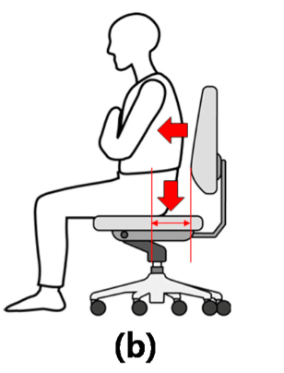

**FIGURE:1.2 SLOUCHING POSTURE**

*(****Source****:https://www.semanticscholar.org/paper/A-Survey-on-sitting-posture-monitoring-systems-Tlili-Haddad/e9c884d951533963d4ae99109859ea03313f2a0d)*

**1.23. NEUTRAL POSTURE**

**Definition and Importance:**

A neutral posture is the ideal alignment of the body, where the spine maintains its three natural curves — cervical (neck), thoracic (upper back), and lumbar (lower back). In this position, the body is in equilibrium, minimizing stress on muscles, ligaments, and joints.

**Body Angles:**

* **Cervical Lordosis:** The neck maintains a 30-40 degree inward curve.
* **Thoracic Kyphosis:** The upper back has a natural curve of 20-45 degrees.
* **Lumbar Lordosis:** The lower back retains a 30-50 degree inward curve.
* **Pelvis:** The pelvis remains in a neutral position, with no excessive tilt forward or backward.

**Biomechanical Benefits:**

1. **Balanced Musculoskeletal System:**
   * In neutral posture, the weight of the body is evenly distributed, reducing the risk of overloading specific muscles or joints. This balance promotes optimal movement patterns and reduces the likelihood of injury.
2. **Spinal Health and Flexibility:**
   * Maintaining the spine’s natural curves reduces strain on intervertebral discs and joints, preventing wear and tear and promoting long-term spinal health. Good posture also improves flexibility, which is essential for physical activity and daily tasks.
3. **Efficient Breathing and Circulation:**
   * Neutral posture keeps the chest open, allowing for full lung expansion and optimal oxygen exchange. Proper blood circulation is maintained, reducing fatigue and promoting muscle recovery.
4. **Joint Longevity:**
   * Joints, including the hips, knees, and shoulders, remain in their optimal alignment when posture is neutral. This reduces the risk of osteoarthritis and joint degeneration, ensuring long-term mobility.

**Long-Term Benefits:**

* Maintaining neutral posture decreases the risk of developing musculoskeletal disorders and joint issues.
* It promotes better energy levels, respiratory efficiency, and overall physical performance.
* Neutral posture supports core strength and balance, reducing the risk of falls and injuries, especially as one ages.

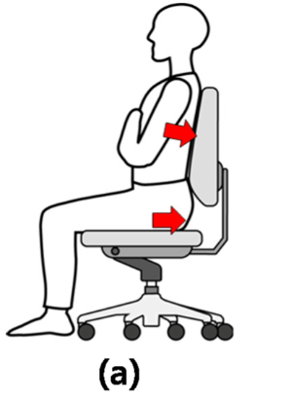

**FIGURE:1.3 NEUTRAL POSTURE**

*(****Source****:https://www.semanticscholar.org/paper/A-Survey-on-sitting-posture-monitoring-systems-Tlili-Haddad/e9c884d951533963d4ae99109859ea03313f2a0d)*

**1.24. LEANING RIGHT**

**Definition and Causes:**

Leaning to the right is a common posture where the body weight is disproportionately shifted to the right side. This may occur while sitting, standing, or walking and is often an unconscious habit. People may favor one leg when standing or shift weight onto one hip when sitting.

**Body Angles:**

* **Spine Tilt:** The spine may tilt laterally by 5-15 degrees to the right.
* **Pelvic Tilt:** The right side of the pelvis may be elevated by 5-10 degrees.
* **Shoulder Drop:** The right shoulder typically drops by 3-5 degrees.

**Biomechanical Effects on the Body:**

1. **Muscular Imbalances:**
   * Prolonged leaning to the right causes the muscles on the right side of the body (e.g., the quadratus lumborum and obliques) to become overworked, while those on the left side weaken. This imbalance can lead to asymmetry in strength and mobility, contributing to discomfort and dysfunction in the lower back and hips.
2. **Pelvic Misalignment:**
   * Uneven weight distribution tilts the pelvis, which can contribute to conditions such as pelvic rotation or leg length discrepancies. Pelvic misalignment also leads to abnormal stress on the lumbar spine, hip joints, and knees.
3. **Spinal Curvature (Functional Scoliosis):**
   * Leaning to one side can cause a temporary lateral curvature of the spine, resembling scoliosis. If maintained over time, this posture can lead to structural changes in the spine and exacerbate back pain.
4. **Shoulder and Neck Strain:**
   * The asymmetrical position of the shoulders causes strain on the trapezius and deltoid muscles, which can lead to tension headaches and reduced shoulder mobility. The leaning posture can also affect neck alignment, causing pain and stiffness.

**Long-Term Consequences:**

* Chronic muscular imbalances can lead to joint pain and instability in the hips and lower back.
* Increased risk of developing scoliosis and other spinal deformities.
* Shoulder and neck pain may become persistent, limiting range of motion and affecting daily activities.

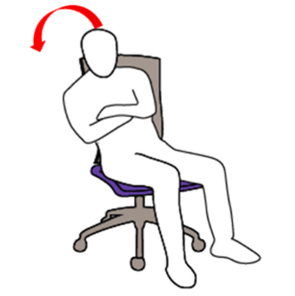

**FIGURE:1.4 LEANING RIGHT***(****Source****:https://www.semanticscholar.org/paper/A-Survey-on-sitting-posture-monitoring-systems-Tlili-Haddad/e9c884d951533963d4ae99109859ea03313f2a0d)*

**1.25. LEANING LEFT**

**Definition and Causes:**

Leaning to the left is a posture where the body weight is disproportionately shifted to the left side. Like leaning right, this posture is often the result of unconscious habits formed during sitting or standing.

**Body Angles:**

* **Spine Tilt:** The spine may tilt laterally by 5-15 degrees to the left.
* **Pelvic Tilt:** The left side of the pelvis may be elevated by 5-10 degrees.
* **Shoulder Drop:** The left shoulder typically drops by 3-5 degrees.

**Biomechanical Effects on the Body:**

1. **Muscle Asymmetry:**
   * Leaning to the left overworks the muscles on that side of the body, particularly the obliques, lower back, and hip muscles. This leads to strength imbalances, contributing to discomfort and potential injury on the left side.
2. **Pelvic and Lower Limb Stress:**
   * The uneven weight distribution can lead to pelvic misalignment, affecting hip function and gait. Over time, this can increase stress on the hip and knee joints, leading to pain and a higher risk of injury.
3. **Spinal Curvature:**
   * Leaning left can create a functional scoliosis, where the spine temporarily curves laterally. Over time, this curvature may become structural, causing more severe back pain and limited mobility.
4. **Shoulder Strain and Impingement:**
   * The left shoulder droops in a left-leaning posture, which can strain the muscles of the upper back and neck. This may lead to shoulder impingement and discomfort, especially during activities that require overhead movement.

**Long-Term Consequences:**

* Muscle imbalances can exacerbate lower back pain and increase the risk of hip and knee problems.
* The left-leaning posture can contribute to chronic spinal misalignment, requiring medical or therapeutic intervention to correct.
* Persistent shoulder and neck pain may develop, limiting upper body flexibility and strength.

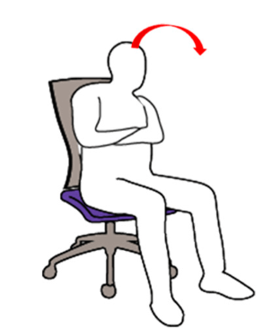

**FIGURE:1.5 LEANING LEFT**

*(****Source****:https://www.semanticscholar.org/paper/A-Survey-on-sitting-posture-monitoring-systems-Tlili-Haddad/e9c884d951533963d4ae99109859ea03313f2a0d)*

* 1. **PROBLEM STATEMENT**

In contrast, vibrational-cue systems rely on Inertial Measurement Unit (IMU) sensors to monitor posture, delivering corrective cues through vibrations. While this approach offers a more seamless experience compared to strap-based systems, it primarily focuses on monitoring cervical posture, potentially overlooking overall posture issues. Users are expected to recognize these vibrations and adjust their posture accordingly.

* 1. **OBJECTIVE**

To enhance the efficacy and user- friendliness of posture correction systems. Efforts are directed towards developing more intuitive and non-intrusive solutions that address the limitations of both strap-based and vibrational-cue systems. By leveraging advancements in sensor technology and user interface design, researchers aim to create posture correction systems that better meet the diverse needs and preferences of users, ultimately promoting improved posture health and overall well- being.

* 1. **NOVELTY**

This work introduces an innovative posture correction system aimed at overcoming the limitations of traditional strap-based methods and enhancing posture monitoring precision. The proposed solution integrates three Inertial Measurement Unit (IMU) sensors strategically positioned at the acromion process (to monitor shoulder position), at T5 of the vertebral column (to monitor the upper and lower back’s combined position) and on the sternum of the body. Through these sensors, this system provides real-time monitoring of sitting posture, offering a more comprehensive approach to correcting sitting posture.

The posture correction system collaborates with a machine learning algorithm that predicts the current sitting postures based on the positional values from the IMU sensors and can be used to provide the user with alert messages.

An essential advantage of our posture correction system lies in its non-intrusive and user- friendly design. By eliminating the need for bulky straps, this system enhances user comfort and convenience, encouraging greater adherence to posture correction routines. Moreover, by incorporating IMU sensors in the acromion process, T5 region and at the sternum our system ensures more precise monitoring of the sitting posture.

A novel strategy for addressing posture-related issues involves employing three IMU sensors placed on the shoulder strap worn by the user to monitor their sitting posture. This automated correction system is designed to encourage the adoption of healthy posture habits and reduce the risk of developing back pain. Through continuous posture monitoring and real-time feedback, the system encourages the consistent maintenance of optimal posture, thereby lowering the likelihood of experiencing chronic back pain.

**CHAPTER 2**

**LITERATURE REVIEW**

**2.1 LITERATURE REVIEW**

In a paper proposed by Hu Luo, TianhaoJin *et al.* [1] a e-skin integrated device for posture monitoring was developed. Using accelerometer attached to a flexible skin (silicone) and vibrational actuators for vibrational cues for the prevention and rehabilitation of cervical spondylosis. This paper describes a new wearable device designed to monitor and correct neck posture.

The device is referred to as electronic skin (e-skin) because it is thin, flexible and conforms to the shape of the wearer’s neck. It is made from a multilayered material that includes a sensor, a processor and actuators. The sensor is an accelerometer, which can detect the position and movement of the wearer’s neck. The processor uses information from the sensor to determine the wearer’s posture. If the wearer’s posture is incorrect, the processor sends a signal to the actuators, which vibrate to provide haptic feedback. This feedback is designed to alert the wearer to their posture and encourage them to correct it.

The researchers behind the e-skin device believe that it has a number of advantages over other posture correction devices. For example, it is more comfortable to wear than devices that use rigid straps or bands. It is also more discreet and can be worn under clothing. Additionally, the haptic feedback provided by the device is thought to be more effective in correcting posture than other feedback methods, such as visual or auditory cues.

The researchers conducted a study to evaluate the effectiveness of the e-skin device. The study involved 20 participants who were asked to wear the device for one hour while performing a variety of tasks, such as using a computer, reading a book, and watching television. The researchers found that the device was effective in improving the participants’ posture. The participants also reported that the device was comfortable to wear and that the haptic feedback was helpful in reminding them to correct their posture.

Overall, the results of the study suggest that the e-skin device is a promising new tool for improving neck posture. The device is comfortable, discreet, and effective in providing feedback to users about their posture. More research is needed to determine the long-term effects of using the device, but it has the potential to be a valuable tool for people who suffer from neck pain or who want to improve their posture.

These are some of the technical details of the device mentioned in the research paper. The e-skin device is made from a flexible, biocompatible material that is waterproof and sweatproof. The sensor is a triaxial accelerometer that can detect the wearer’s neck flexion, extension, and lateral bending. The processor is a low-power microcontroller that is responsible for collecting data from the sensor, determining the wearer’s posture, and controlling the actuators. The actuators are small, coin-shaped devices that vibrate to provide haptic feedback.

Hung-Yuan Chung,Yao-Liang Chung *et al.* [2] have developed a posture correction system involving a smart necklace, computer notebook and a smartphone , the computer notebook with depth camera accesses the skeletal structure and joint reference points and the smart necklace accesses gravitational acceleration and sends alert messages to the smart phone of the user . This device effectively allows the user to monitor and correct their posture. The system utilizes wearable technology for user-friendly posture monitoring and correction.

A key component is a "smart necklace" equipped with sensors to detect body movements and posture. The system also involves a computer with a depth camera. This camera captures images to establish a baseline for the user's ideal posture, which is then used to calibrate the necklace's standard posture settings. Finally, a smartphone app integrates with the necklace. When the necklace detects poor posture, it transmits a signal to the app, prompting the user to correct their form.

This innovative system offers several advantages. Unlike bulky corrective garments, it allows users to monitor and adjust their posture independently. Additionally, the depth camera streamlines calibration, and wireless communication between devices eliminates the need for complex wiring. Overall, this technology presents a promising approach to promoting good posture and potentially improving spinal health.

Jun Zhang, Hui Zhang *et al*. [3] have proposed a Wearable Robotic Device (WRD) and Consumer Electronic Devices (CED) where the WRD monitors the posture of the patient and alerts the patient through the CEDs which can also be viewed by a doctor remotely through cloud. This research paper introduces a novel wearable robotic system designed to address body posture concerns. The system tackles three key areas. First, it acts as a monitoring tool, keeping track of the posture of various body segments, providing valuable data on a person's overall posture. The system goes beyond monitoring by actively detecting poor posture. When deviations from proper alignment are identified, it delivers prompts or reminders to the user, encouraging them to correct their posture in real-time. Finally, the system has the potential to play a role in posture rehabilitation processes, potentially aiding individuals recovering from posture-related injuries or conditions.

The system itself consists of two main parts. The first is a wearable robotic device (WRD) worn by the user. It likely houses sensors to monitor posture and might incorporate feedback mechanisms like vibration or visual cues to nudge the user towards proper alignment. The second component consists of consumer electronic devices (CEDs) such as smartphones or laptops that connect wirelessly with the WRD. The CEDs likely process and display posture data collected by the WRD. This data visualization can empower users to understand their posture habits. Additionally, the system might allow for data to be uploaded to the cloud, enabling remote monitoring by healthcare professionals if the design facilitates such functionality.

Overall, this research explores a promising wearable robotic system that could be valuable for individuals seeking to improve or maintain good posture. The potential benefits include improved posture awareness, reduced risk of posture-related problems, and potential support for posture rehabilitation.

Krutika Bramhapurikar, Arohi Prabhune *et al.* [4] have developed a low-cost device with flex sensor and vibrational motors for neck bending and sends vibrational and message alerts for posture correction when the person is in a wrong posture. This research paper explores a wearable posture corrector device designed to improve a person's posture habits. The device, likely worn on the back or torso, incorporates sensors to detect the user's posture and identify deviations from proper alignment. When poor posture is detected, the device provides feedback mechanisms to encourage correction. This feedback might involve vibration, electrical stimulation, or visual/auditory alerts displayed on a connected app.

The potential benefits of this wearable posture corrector are numerous. Real-time feedback can help users become more mindful of their posture throughout the day. The device's prompts can encourage users to adjust their posture and develop better posture habits over time. Maintaining good posture can help prevent back pain, muscle strain, and other potential health issues associated with poor posture.

Overall, this research explores a wearable solution for promoting good posture. The paper might delve deeper into the technical details of the device, its effectiveness through user trials, and potential advantages over existing posture correction methods. The goal is likely to develop a user-friendly and effective tool that can benefit individuals seeking to improve their posture and potentially enhance their overall well-being.

Rik Bootsman,Panos Markopoulos *et al.* [5] have developed a smart garment ‘BackUp’ for assisting lumbar posture correction and maintenance in nurses using an accelerometer integrated shirt and a feedback strategy through messages for changing the posture of the user. The author’s research into wearable technology suggests it has promise for monitoring and improving posture in the workplace. Traditionally, maintaining good posture relied on self-awareness and reminders, which can be unreliable. Wearable tech offers a solution by providing real-time feedback and data on a user's posture throughout the day.

The core technology in most wearable posture monitors is inertial measurement units (IMUs). These sensors detect the wearer's body position and movement, allowing the device to assess posture. When deviations from ideal alignment are identified, the device provides feedback to the user. This feedback can come in various forms, like vibration, visual cues on a connected app, or gentle audio reminders.

There are several potential benefits to using wearable posture monitors in the workplace. Improved posture awareness can lead to a reduction in musculoskeletal disorders, a common problem for office workers who sit for extended periods. Additionally, good posture can contribute to increased comfort and focus, potentially leading to improved productivity.

While further research is needed to fully understand the long-term effectiveness of wearable posture monitors in workplaces, the potential benefits for employee health and well-being make this a promising area for continued exploration and development.

Seung-Min Lee *et al.* [6] presented a novel assistive chair design aimed at correcting sitting posture issues caused by prolonged sitting. It utilizes pressure sensors and ultrasonic sensors to monitor the user's posture in real-time. Raspberry Pi controls the system, providing feedback through alarms and LED notifications when posture deviations are detected. The chair prompts users to adjust their posture and even provides stretching recommendations after prolonged sitting. Through extensive testing, including function tests and posture analysis experiments, the effectiveness of the chair in correcting posture is demonstrated. The results indicate that the chair successfully assists users in maintaining proper sitting posture. Notably, after a week of usage, significant improvements in posture are observed among participants. Overall, the assistive chair shows promise as a practical solution for promoting healthier sitting habits and preventing related health issues caused by poor posture. Further improvements and long-term studies are suggested to enhance its effectiveness and user experience

Abdull Hannan *et al.* [7] introduced a fully portable smart fitness suite designed to assist users in performing exercises correctly without the need for a physical gym trainer or gym environment, addressing the challenges posed by high-intensity workouts and improper posture. It focuses on two exercises, T-bar and bicep curls, with the aid of a real-time Android application acting as a virtual gym trainer. The suite incorporates gyroscope and EMG sensory modules to detect movements and muscle health, providing alerts for unhealthy posture and guidance for achieving the best posture based on sensor values. A KNN classification model is employed for prediction and guidance during exercise sessions through the Android application's text-to-speech feature, achieving an 89% accuracy rate. The proposed system includes features such as real-time muscle health detection and fatigue prevention using EMG sensors, along with workout tracking, BMI analysis, and daily workout challenges through the Android application. The system's performance is evaluated using statistical validation, achieving high accuracy, precision, recall, and F1-measure scores, particularly with the KNN classification model. Future improvements could include expanding the suite's exercise repertoire, addressing gyroscope drift issues, and tailoring the system for specific user demographics.

Ranjith Shanther *et al.* [8] performed a study that focuses on addressing the issue of poor posture, which can lead to chronic musculoskeletal disorders, particularly among office employees who spend prolonged periods sitting. Despite efforts to maintain proper posture, unintentional deviations often occur. To mitigate this problem, the study proposes a wearable device that alerts users when they deviate from optimal posture for extended periods. Testing conducted at an individual level revealed promising results, suggesting the device has significant potential to attract users with certain modifications.

The device's performance was assessed by attaching it to users and monitoring sensor readings via a mobile Bluetooth application while they varied their posture. Observations included satisfactory tracking of posture changes in the cervical and thoracic regions, effective calibration to memorize the user's neutral spine position, and practical haptic feedback via vibrations for minimal intrusion.

However, challenges were noted, such as the stiffness of the device material, difficulty in adhering it to the user's back, and its bulky size and weight, which hindered proper positioning. Despite these limitations, the study highlights the significant change in sensor values when posture shifts, particularly in the cervical and thoracic regions. It notes that while the cervical accelerometer accurately reflects upper torso inclination, the lumbar flex sensor may fail to register transitions due to device material stiffness obstructing curvature detection. The discussion emphasizes the need for improvements in device design and materials to enhance accuracy and user comfort, suggesting areas for future expansion and additional features to be included.

Ionut-Cristian Severin *et al.* [9] This research introduces a novel head posture recognition system utilizing three inertial sensors. The developed device integrates a real-time monitoring system assessing three risk posture factors and provides audio feedback when the user's posture deviates beyond established thresholds. The application aims to prevent and correct chronic bad posture, such

as neck and back pain. Experimentation involved calibrating the posture system and evaluating volunteer participants' posture simulations, including sitting and standing positions. The system effectively distinguished between good and bad posture, achieving an 80% classification rate.

Notably, when incorrect posture was detected, the system sent a notification with an emergency message, demonstrating its functionality in real-time posture correction.

The system's portability and ease of use make it suitable for daily office tasks. In conclusion, the research proposes a cost-effective wearable device for preventing and correcting poor head posture, highlighting its potential for further development and application in healthcare. Future research aims to explore head posture risks during various daily activities using machine learning algorithms and implement a Windows application for enhanced communication and feedback.

Gabriela Cajamarca *et.al* [10] presented a wearable device aimed at identifying the bodily postures of older individuals while also examining user perceptions. Thirty older participants engaged in various physical activities, and data was classified offline, achieving a 93.5% accuracy rate. User perception of the device was positive, with participants rating usability and overall experience highly. Descriptive statistics revealed differences in sensor data distribution across different postures, with leaning forward showing marked variation. Posture classification using a decision tree algorithm yielded a 93.5% accuracy rate, with walking activity causing the most confusion.

Further analysis suggested that using all three sensors provided the best classification accuracy. User experience evaluation via the AttrakDiff questionnaire indicated positive perceptions of the device's appearance and usability. Interviews revealed participants' comfort with the device and their motivations and expectations regarding its use. Overall, the device was well-received by older users, demonstrating potential for use in monitoring posture and promoting physical activity in this demographic. Limitations included the short duration of participant use and the specific demographic studied. Future research should explore long-term usage and involve a more diverse older population.

Federico Roggio, Silvia Ravalli, Grazia Maugeri *et al.* [11] have proposed novel electronic devices in motion and posture analysis, describing their strengths and weaknesses. Advancements in technology for motion and posture analysis are rapidly developing, particularly in rehabilitation and sports biomechanics. These advancements necessitate clear distinctions among different measurement systems to allow for appropriate application in various situations.

The field of motion and posture analysis has seen significant advancements, particularly in the realms of rehabilitation and sports biomechanics. This progress necessitates the ability to clearly distinguish among various measurement systems to ensure their appropriate application in different contexts. This review provides an overview of the currently utilized motion and posture analysis systems and offers guidance on selecting the most suitable approaches for specific scenarios.

Traditional gold-standard systems for motion analysis, such as optical motion capture with markers, have been extensively used in clinical settings. However, they come with challenges such as complex marker placement and lengthy procedures. Fully automated and markerless systems are addressing these drawbacks, offering efficient and precise biomechanical analysis, especially in natural environments outside laboratory settings.

Similarly, modern posture analysis techniques are emerging to meet the demand for fast, non-invasive methods that yield high-precision results. These technologies have proven effective for children and adolescents with non-specific back pain or posture-related issues. The evolution of these methods aims to standardize measurements and provide practical tools for clinical practice, facilitating early diagnosis of musculoskeletal pathologies and monitoring patient progress.

The review outlines these innovative devices and their applications, serving as a comprehensive guide for researchers, clinicians, orthopedics, physical therapists, and sports coaches. By leveraging these advanced technologies, professionals can enhance their practice in diagnosis, therapy, and prevention, ultimately improving outcomes for patients across various age groups and health concerns.

Srijan Verma, Nandha Kumar Thulasiraman and Andy Chan Tak Yee [12] have proposed a Field Programmable Gate Array (FPGA) and gyroscope-based concept design for alleviating back pain and improving form by offering lumbar support in real time. Poor posture is a widely recognized issue that can lead to a variety of health complications, affecting individuals from toddlers to the elderly. This posture can be compromised due to various reasons such as serious injuries, surgeries, or birth defects. Long-term effects of poor posture extend beyond just orthopedic issues and can also result in nervous system complications and cardiovascular problems.

To address these issues, the paper presents a concept design based on Field Programmable Gate Array (FPGA) and gyroscope technology. This design aims to provide real-time lumbar support and improve overall form for the user. The system uses three gyroscopes placed strategically on the user's back to accurately measure body orientation and posture.

The data collected from the gyroscopes is processed through a digital design implemented using Very high-speed integrated circuit Hardware Description Language (VHDL). This digital design processes the data efficiently and accurately, allowing for immediate analysis and feedback regarding the user's posture.

The proposed system not only provides real-time support and feedback for maintaining good posture but also has the potential to alleviate back pain and improve overall form. By providing a high level of precision and adaptability, the design represents a significant step forward in addressing posture-related health issues.

In summary, the FPGA and gyroscope-based design offers a novel and effective approach to improving posture and alleviating back pain in real-time. With its high accuracy, versatility, and adaptability, the system has the potential to become an essential tool for individuals looking to maintain optimal posture and overall health.

Joon-Gi Shin, Eiji Onchi , Maria Jose Reyes, Junbong Song, Uichin Lee *et al*. [13] designed a robotic monitor that moves imperceptible to counterbalance unbalanced sitting postures and induces posture correction. Musculoskeletal discomfort is often caused by prolonged static and unbalanced sitting postures during computer usage. This paper explores an innovative solution to this problem by investigating the use of a very slow-moving monitor to achieve unobtrusive posture correction.

In a preliminary study, researchers identified display velocities below the perception threshold, observing how users unconsciously responded by gradually following the monitor's motion. Building on these findings, the researchers designed a robotic monitor that subtly moves to counterbalance unbalanced sitting postures and induce posture correction without the user being consciously aware.

In an evaluation study with 12 participants, the researchers compared user experiences while working for four hours both with and without the prototype monitor (for a total of eight conditions). The study found that the monitor's actuation led to an increase in non-disruptive, swift posture corrections, significantly reducing the duration of unbalanced sitting postures.

Most users appreciated the monitor's assistance in correcting their posture and reported feeling less physical fatigue as a result. This positive feedback suggests that the monitor successfully facilitated unobtrusive behavioral changes, helping users maintain healthier postures during prolonged computer usage.

The concept of using slow robots, such as the robotic monitor in this study, marks an important step toward incorporating actuated objects in our daily lives for unobtrusive behavioral changes. This approach opens new possibilities for enhancing ergonomics and health in environments where computer usage and static sitting postures are prevalent.

Jeremy A. Steeves, Heather R. Bowles, *et al*. [14] The purpose of this study was to compare the classifications of sitting, standing, and stepping from two types of wearable monitors—the ActiGraph and activPAL—when worn on the thigh under both laboratory and free-living conditions. The aim was to determine the accuracy of these monitors in identifying different activities and to assess how well the two devices agreed in their classifications.

In the study, adult participants wore both the ActiGraph and activPAL monitors on their right thigh while they performed a series of activities in a controlled laboratory setting, including six sitting, two standing, nine stepping, and one cycling activity. Additionally, participants engaged in an activity involving writing on a whiteboard with intermittent stepping.

The study also assessed the monitors' performance in free-living conditions over a period of three days, during which participants wore both monitors while going about their daily routines. This approach aimed to simulate real-world usage and provide insights into the monitors' ability to classify activities outside a controlled environment.

To evaluate the monitors' performance, the researchers calculated the percent time correctly classified under laboratory conditions. They also assessed between-monitor agreement and weighted kappa (κ) under free-living conditions to quantify the level of agreement between the ActiGraph and activPAL monitors.

The study's findings can provide valuable information about the strengths and limitations of each monitor, particularly in their ability to classify sitting, standing, and stepping activities accurately. This information can be useful for researchers and practitioners who use wearable activity monitors in health and fitness research or clinical practice.

P M Grant, C G Ryan, *et al.* [15] The study's background emphasizes the importance of accurately measuring physical activity patterns to identify sedentary behaviors and potentially guide interventions to decrease inactivity. In this context, it is critical to evaluate devices such as the activPAL physical activity monitor to understand their effectiveness in measuring posture and motion during everyday activities.

The study's objective was to assess the performance of the activPAL monitor by comparing its measurements with visual observations, which served as the criterion standard. By doing so, the researchers aimed to validate the monitor's accuracy and reliability in detecting various postures and motions, including walking, standing, and sitting.

To achieve this, the study recruited 10 healthy participants who wore three activPAL monitors simultaneously. The participants engaged in a series of randomly assigned everyday tasks that involved walking, standing, and sitting. Each task was recorded using a digital camera to capture the participants' activities.

The digital recordings were then synchronized with the output from the activPAL monitors. This synchronization allowed the researchers to visually classify the time participants spent in different postures, such as sitting, standing, and walking. The visually classified data served as the benchmark for comparison with the activPAL's measurements.

By comparing the activPAL's output with the visual classification of postures, the study aimed to evaluate the monitor's accuracy and reliability. This approach would provide insight into whether the activPAL monitor can effectively measure physical activity patterns and posture changes during everyday activities. Accurate and reliable devices like activPAL are essential for assessing sedentary behavior and developing targeted interventions to improve health outcomes and reduce inactivity.

Emilio Sardini, Mauro Serpelloni, *et al.* [16] have developed a wireless Lycra T-shirt with an inductive sensor is designed to prevent spinal deformities and effectively monitor a subject's posture during rehabilitation exercises. This system captures the subject's posture by measuring the deformation of the T-shirt, and the sensor's output is a voltage that varies with the T-shirt's deformation. The data is transmitted wirelessly for ease of use and comfort, and the design emphasizes independence from a remote unit, ensuring the T-shirt is lightweight, comfortable, and user-friendly.

The experimental setup involves comparing the T-shirt's output data with data from an optical system that measures marker positions on the patient's back and chest, serving as a gold standard for comparison. Testing with four subjects on different days showed that the T-shirt consistently provided reliable data on par with the optical system's measurements. The sensor’s simple design, using a copper wire and separable circuit board, enables straightforward and effective monitoring. When combined with conditioning and transmission electronics for remote communication, the sensorized T-shirt supports postural monitoring during rehabilitation exercises. Its non-invasive nature makes it a comfortable choice for patients, offering a practical and effective approach to monitoring posture and preventing spinal deformities.

The wearable wireless T-shirt measures deformation from different postures during rehabilitation exercises to help patients improve posture and prevent spinal deformities. An inductive sensor sewn into the fabric changes impedance based on body movement, and an electronic circuit converts this to voltage to assess posture quality. Biofeedback signals (vibrations) support therapeutic approaches, activated by an algorithm based on physician recommendations.

The T-shirt uses resonance frequency for reference and adjusts automatically with a direct digital synthesizer (DDS) according to the patient's posture. The system's accuracy is validated against an optical measurement system, with testing showing a maximum experimental uncertainty of about 4.9 mm, considered sufficient for the application.

The T-shirt is washable for durability, with enameled copper wire protecting the sensor from environmental influences and skin contact. The circuit board processes data on the T-shirt and transmits it remotely via the internet, reducing unnecessary travel and optimizing clinical resources.

Lightweight and non-invasive, the T-shirt ensures patient comfort and ease of use with its simple design using commercial copper wire and a separable electronic circuit board. Ongoing research aims to improve the prototype's performance and reduce electronic consumption.

Calista Huang, Jim Kelly *et al.* [17] has proposed back pain is a major cause of disability worldwide, hindering people's ability to work and participate in daily activities. Proper posture alleviates stress on supporting ligaments and muscles, supporting overall spinal health. However, posture relies on automatic muscle support, making it challenging to improve consciously. Over time, habitual muscle strain can develop, making it harder to correct posture. Prolonged sitting or standing contributes to poor everyday posture habits, leading to various postural issues. The consequences of poor posture include spinal misalignment, back pain, sore muscles, restricted lung function, blood vessel constrictions, abnormal gait, and a higher risk of injury.

Early intervention is key to preventing long-term negative health outcomes. An easy-to-use posture monitoring device can help avoid these negative effects. This project developed a wearable garment with three flex sensors located in the front, left, and right directions that track and monitor changes in spine curvature. The garment provides real-time feedback on back posture and sends vibrations to notify the user to change position when necessary. This device can help enhance posture habits, lower health risks, and improve users' quality of life.

The project focused on developing a straightforward, wearable posture monitoring device that alerts users to poor posture and helps them adopt better habits. Poor back posture is a prevalent issue with lasting effects, and conscious improvement can be difficult. The project showed that wearable posture monitoring devices are effective and practical for users looking to enhance their posture. These devices provide a convenient way to maintain proper posture during work periods and are cost-effective, with materials costing around $65. However, additional research is necessary to evaluate long-term outcomes and confirm findings on wearable haptic devices. Future interest includes introducing this technology to the commercial market, which will require consistent performance and user-centered improvements. Medical professionals should consider wearable technology as a straightforward tool for supporting patients' healthy habits. Additionally, more assessment is needed to measure the effect of wearable devices on overall pain or comfort to ensure users benefit significantly.

Francesca Cordella, Francesco Scotto di Luzio *et al.* [18] have employed a system that monitors workers' posture online using M-IMU sensors to prevent musculoskeletal disorders and eliminate the need for bulky wearable systems. The approach incorporates tactile biofeedback signals, interpreted by the central nervous system, to guide workers in adjusting their trunk and head posture during working hours. Ten healthy subjects participated in tasks such as moving loads under conditions with and without vibrotactile feedback. The comparison demonstrated that feedback encouraged participants to adjust their neck and trunk posture correctly, while those without feedback often held positions that could lead to musculoskeletal problems.

The research highlights the critical role of feedback in helping workers modify their posture and minimize the risk of related issues. Vibrotactile feedback emerged as a valuable tool for encouraging proper posture and enhancing workplace ergonomics. These findings offer potential avenues for creating interventions that support workers in maintaining healthy postures and preventing injuries on the job.

The study investigated how a biofeedback-based approach can assist workers in maintaining proper ergonomic postures during their tasks. Researchers designed and tested a compact, wearable system using M-IMU sensors to monitor trunk and head posture changes during task execution. The system provides real-time feedback to correct posture by sending relevant information to the feedback device and user. Ten healthy subjects participated in the study, engaging in tasks such as moving loads, an activity commonly linked to musculoskeletal disorders (MSDs). The findings demonstrated that providing feedback significantly improved user posture, showcasing the system's effectiveness. The study supported the feasibility and ease of using vibrotactile feedback for posture correction.

Further research is needed to extend the study's scope to encompass various working tasks and actions. The researchers also aim to incorporate EMG and M-IMU sensors in the Myo Armband to monitor worker muscular activity and reconstruct shoulder joint angles. Additionally, plans to diversify feedback modalities and adapt the system to human-robot interaction in work environments are underway. These future developments present promising opportunities for research and development, aiming to enhance workplace ergonomics and mitigate musculoskeletal risks for workers.

Pavana Pradeep Kumar, Krishna Kant *et al.[*19] proposed a paper which presents a spatial-temporal reasoning infrastructure that uses RGB-D camera views to estimate pose-relevant angles in real-time. This technology is essential for ensuring correct posture in various human activities, such as working on computer screens and performing arts, which are important for safety and performance. The study shows that pose-relevant angles can be accurately estimated using RGB-D cameras. The method uses spatial-temporal reasoning on top of basic computer vision algorithms to determine poses from 2D human stick models and further enhances accuracy by incorporating depth information to assess angles and compare them against standards.

The technique can be applied to different scenarios, including knowledge workers sitting in front of computer screens and tae-kwando, where pose transitions are critical. The method stands out as it requires no additional training and surpasses other methods in both accuracy and speed. By leveraging depth information, the approach offers potential across various domains were maintaining correct posture and tracking pose transitions are crucial. The ability to estimate poses has significant implications quickly and accurately for ergonomics, safety, and performance across a range of activities, demonstrating the versatility and effectiveness of the approach.

The study assesses the performance of a proposed posture recognition model by evaluating its accuracy in determining both the correctness of a given posture and the accurate sequence of pose transitions. Using the Xsens system, 3D sensor data from 17 sensors positioned on the subject's body is recorded and labeled with one of five sitting postures for analysis on the Posture Dataset.

The posture recognition framework processes each frame individually, utilizing OpenPose to calculate 3D body joint locations and angles connecting these key points. The resulting 3D output is compared to ground truth data to gauge accuracy. In the Taekwondo dataset, video frames are labeled with pose transitions corresponding to specific belt patterns.

Comparisons are made between the proposed posture recognition and pose transition framework and state-of-the-art machine learning, time series, and deep learning models. These models receive input consisting of 3D coordinates of body joint locations and associated angles, categorized by one of five sitting postures. Furthermore, the models use frame-wise labeled pose transitions to identify the correct sequence of transitions.

A decision function aids in determining if the sequence of posture transitions aligns with a specific belt pattern. This evaluation allows for an assessment of the proposed framework's efficacy relative to other advanced methods.

David Odesola, Janusz Kulon [20] proposed a smart-sensing chairs highlights the dangers of poor sitting posture, including spinal misalignment, muscle tone imbalance, and musculoskeletal disorders. Smart-sensing chairs with advanced sensor technologies offer a potential solution by providing real-time detection, classification, and monitoring of sitting postures to minimize the risk of musculoskeletal issues. The review examines existing research on these chairs, focusing on posture detection and classification methods, as well as the effectiveness of various sensor technologies. A comprehensive search across databases found 34 relevant studies that employ non-invasive techniques for posture monitoring.

Force Sensing Resistors (FSR) are the most common sensors for posture detection due to their affordability and ease of use. Convolutional Neural Networks (CNN) and Artificial Neural Networks (ANN) are the main machine learning models used for posture classification. However, the review points out that despite using CNNs and ANNs, they fall short compared to traditional statistical models in classification accuracy due to the limited size and diversity of training datasets. These datasets often lack representation of various human body shapes and musculoskeletal conditions. Furthermore, the review highlights a major gap in the assessment of user feedback mechanisms, which are crucial for notifying users of their sitting posture and encouraging corrective measures. This gap emphasizes the need for a comprehensive evaluation of smart-sensing technologies and user feedback methods to improve posture monitoring and outcomes.

The paper proposes about smart-sensing chair systems, outlining the diverse range of sensors used across studies, including Force Sensing Resistors (FSR), textile pressure sensors, load cells, and image sensors. Among these, FSR sensors are the most employed by researchers. The review examines two strategies for sensor placement: using a pressure sensor array or distributing individual sensors throughout the chair. While dispersed sensor placement provides benefits in terms of maintenance and cost, it may not be ideal for people with musculoskeletal disorders (MSDs).

Machine learning models are utilized for sitting posture classification, many achieving high accuracy rates up to 90%. However, the paper highlights a gap in the quality of training datasets, typically based on healthy subjects simulating incorrect postures, which could limit the models' applicability for broader populations, particularly those with MSDs. Future research should prioritize the development and thorough evaluation of user feedback systems for posture correction in practical settings.

Integrating various sensor types offers potential for advancing smart-sensing chair systems. Combining sensor technologies like infrared reflective distance sensors with pressure sensors, as demonstrated by Jeong and Park, can enhance posture classification versatility. Incorporating Inertial Measurement Unit (IMU) sensors may enable user activity monitoring, providing more comprehensive data for posture analysis and correction.

**2.2 MARKET SURVEY**

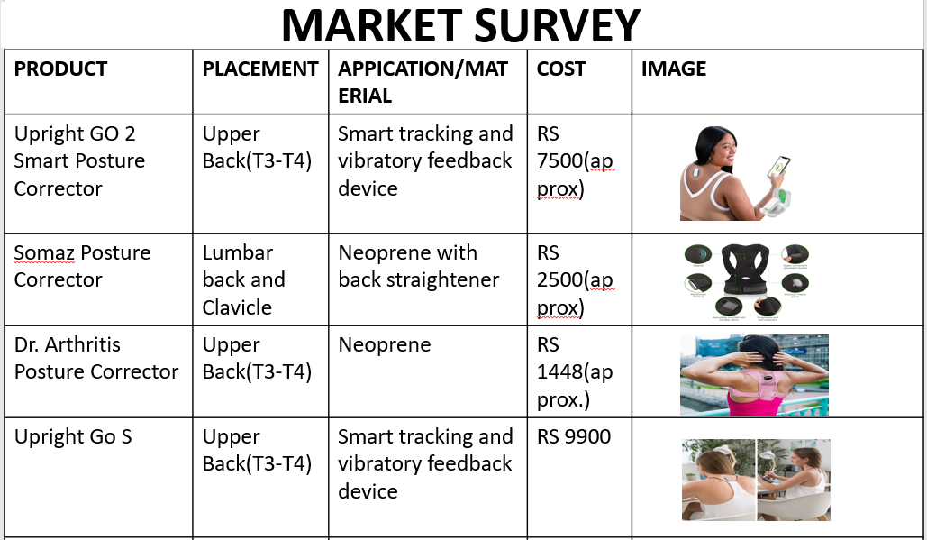

**2.3 PATENT SEARCH**

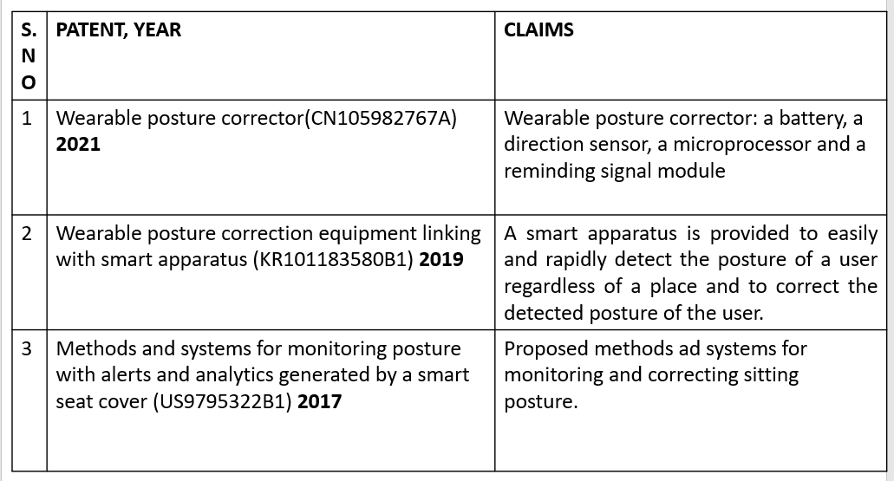

**CHAPTER 3**

**MATERIALS AND METHODOLOGY**

**3.1 MATERIALS AND CIRCUITRY**

This study aimed to develop a posture monitoring system using a machine learning algorithm to assess and classify shoulder and upper back posture. The system employed three MPU-6050 sensor to capture accelerometer data, which was then processed to determine tilt angles and fed into a K-Nearest Neighbour algorithm for posture classification.

### Materials

* **Hardware:**
  + Raspberry Pi Pico: A microcontroller board serving as the central processing unit for the system.
  + MPU-6050 Sensor: A six-axis motion sensor incorporating a gyroscope and accelerometer used to capture posture data.
  + Neoprene Velcro Shoulder Strap: A comfortable and adjustable strap to securely mount the MPU-6050 sensor on the subject's acromion process (shoulder tip) ,T5 vertebra (upper back) and the Sternum.
* **Software:**
  + Platform: Two platforms were explored for developing and running the machine learning model:
    - Spyder: An open-source Python integrated development environment (IDE) offering a user-friendly interface for code development and data analysis.
    - Google Colab: A cloud-based platform providing free access to powerful computing resources, enabling model training on larger datasets.
  + Programming Language: Python: A versatile and widely used programming language well-suited for machine learning applications due to its extensive libraries and ease of use.
  + Libraries:
    - Scikit-learn: A popular machine learning library in Python offering various algorithms and tools for data preprocessing, model training, and evaluation.
    - Pandas: A library for data manipulation and analysis, facilitating data organization and feature extraction.
    - Matplotlib: A library for creating informative visualizations of data, enabling posture classification results to be presented graphically.

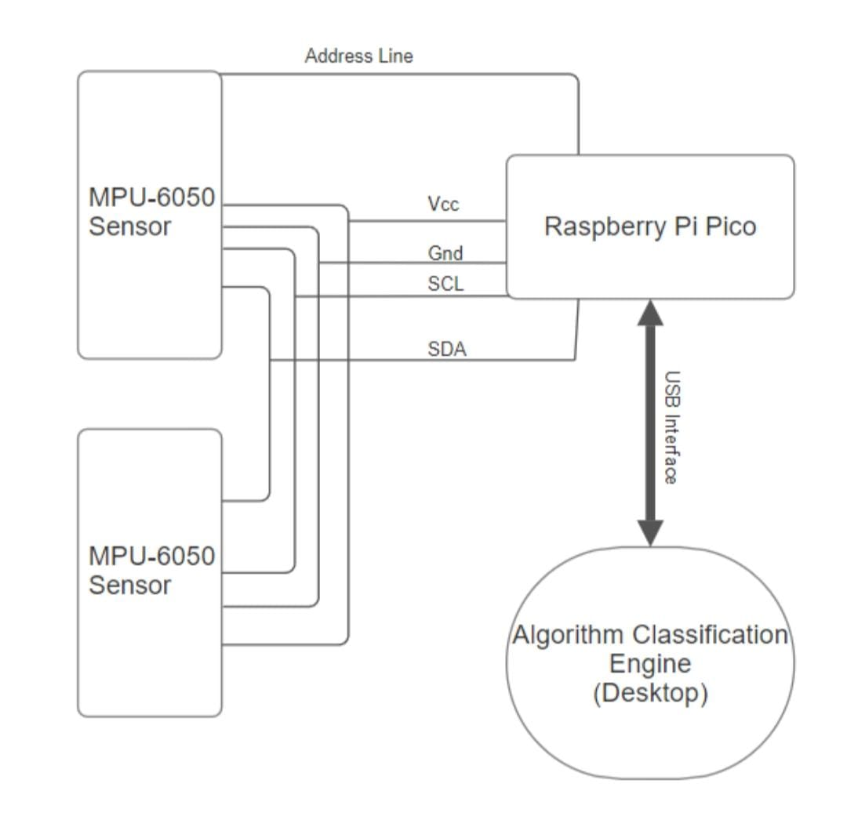

**FIGURE 3.1: PROTOTYPE CIRCUITRY**

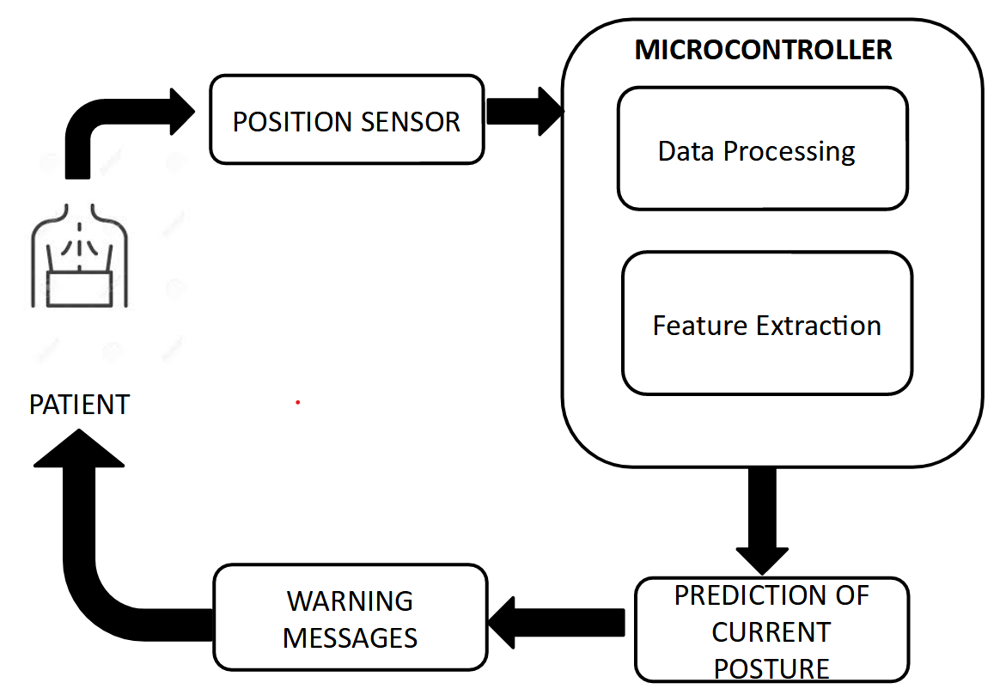

**FIGURE 3.2 : PROPOSED METHODOLOGY OF THE SYSTEM**

### 

### 

1. **(B) (C)**

**FIGURE 3.3 : COMPONENTS USED (A) MPU-6050,(B) RASPBERRY PI PICO, (C) HC-05 (BLUETOOTH MODULE)**

### **3.2 SYSTEM DESIGN**

Our system's operation primarily depends on the data acquired by IMU sensors placed on the body, which are then pre-processed to extract features. These features are then fed to a classifier to identify the user's sitting posture, therefore notifying the user.

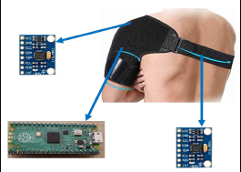 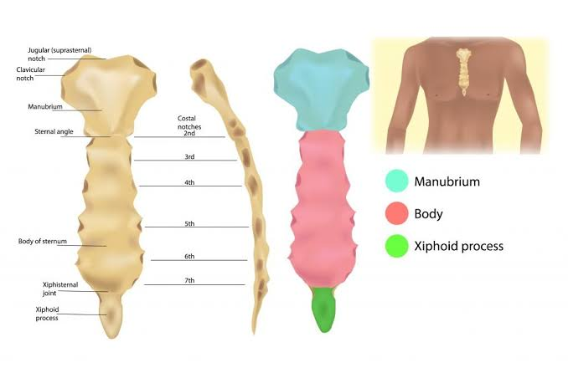

**FIGURE 3.4: SENSOR PLACEMENT**

## **3.2.1 Design:**

Our system is designed to extract movement and orientation-related data during sitting posture from three different locations as given in Figure 3.4. These locations are:

* The Acromion Process
* The T5 vertebra
* The Sternum (SAII)

The Acromion Process and T5 vertebra were chosen due to their remarkable accuracy in existing posture monitoring systems that use IMU sensors. This is understandable due to the significant deviation in location and orientation during postural changes. The thoracic junction is used to counterbalance the system's bias toward the posterior of the body with the T5 vertebra. This location proved to be the best for extracting data from the anterior of the body.

The placement of these sensors was achieved using a Neoprene Velcro shoulder strap, as described in Figure 1. This adjustable shoulder strap covers all three mentioned areas and was used to embed the sensors within. Care was taken to avoid letting the shoulder strap's influence affect the user's normal posture. The Acromion and T5 sensors were fixed, whereas the chest sensor was adjustable to relocate it to the correct position for individuals with different body widths. The sensors used for this purpose were MPU-6050s, which are capable of acquiring 6 degrees of freedom (DoF), namely, acceleration and rotational speed on all three axes. This data could be transmitted through the I2C medium, allowing fast multi-device communication, aiding our purpose, and operating at low power.

The processing unit was located near the sensors and was embedded within the strap near the Acromion Process, as this area had enough space to hold the MPU. The processing unit was connected to the sensors via a series of wires designed to align with the strap's structure. Some limitations were noted in

its placement, with reports of discomfort due to its inflexible structure. The objective of our system is to improve processing and classification; therefore, the processing unit's size was reduced as much as possible but ideally needs to be flat and flexible with zero protruding height. The Raspberry Pi Pico was chosen for its small size and ample memory (20kb SRAM). It also includes built-in libraries for the future prospect of embedding ML algorithms. Additionally, it is low power.

A BLE module was used to transfer relevant data to the classifier on the PC. The HC-05 module was selected for its accessibility to high speeds and low power operation.

The classifier was run in the background on the user’s PC. It classified data received from the BLE module and presented relevant information to the user as needed. The classifier chosen for this purpose was KNN, as it demonstrated better performance in a set of experiments detailed in the following sections. The classifier took a mean time of 1.5 seconds for inference.

## **3.2.2 Operation**

Once the shoulder strap embedded with the sensors and processing unit is worn by the user, they are expected to perform a calibration routine. This routine is conducted to eliminate the zero-error arising from the gyroscopic measurements for each user. During this 10-second routine, the user sits in a static neutral posture, as depicted in Figure 8. The zero-error bias is calculated by averaging the static gyroscopic signal.

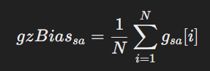

Each sensor outputs a 6-DoF measurement, namely, acceleration and rotational speed on all three axes. Each sensor is sampled at 45Hz, given the processing limits of the Pico. While the acceleration signal is not pre-processed, the gyroscopic signals are altered by subtracting the zero-error bias value calculated during the calibration routine. This adjustment allows the gyroscope to output true zero values. The processing unit then acquires these signals and processes them to extract new information, known as tilt. The tilt is calculated in two ways: using a complementary filter and using only acceleration signals.

The complementary filter considers both acceleration and gyroscopic observations to calculate the tilt using the formula depicted below. The complementary filter effectively combines the low-frequency stability of the accelerometer (which measures tilt based on gravity but is susceptible to noise from linear movements) with the high-frequency responsiveness of the gyroscope (which tracks rotation but drifts over time). This fusion helps maintain a more reliable and stable estimate of tilt angles, reducing noise and drift. It applies a weighted combination of the accelerometer and gyroscope data. The optimal weight chosen is 0.95. The formula is further advanced to wrap the signal around +180 to -180 degrees to better compensate for the drift accumulated by gyroscopic readings. Despite the complementary filter's advantage over the acceleration-based tilt, due to the static nature of sitting postures, both methods are taken into account.

* θX​[n] is the filtered tilt angle for the X-axis at the current loop iteration.
* θX[n−1]\theta_X[n-1]θX​[n−1] is the tilt angle from the previous iteration.
* θAccX\theta_{\text{AccX}}θAccX​ is the angle derived from accelerometer data for the X-axis, calculated using
* θ˙GyroX​⋅Δt is the change in angle from the gyroscope data between sampling period, where θ˙GyroX​ is the angular velocity from the gyroscope for the X-axis, and Δt is the time step between each sample.
* α is the complementary filter weight which we’ve found best operated at a value of 0.95



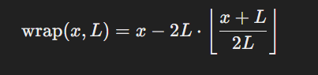

here wrap is defined as above, where:

x is the input angle.

* L is the limit (e.g., L=180Deg)
* ⌊y⌋ is the floor function, which returns the greatest integer less than or equal to y.

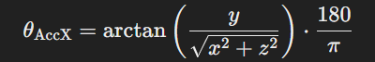

From all the extracted features, the meaningful ones are sent to the classifier via the BLE module using a UART module to communicate with the processor. The classifier then identifies the user's posture and displays it to them via an application.

**CHAPTER 4**

**DATA COLLECTION AND ANALYSIS**

**4.1 DATA COLLECTION:**

The data collection process focused on recording motion and orientation data from 14 participants using the MPU6050 sensor. This sensor, which integrates both an accelerometer and gyroscope, was used to capture detailed movement data along three axes (x, y, and z) while participants performed specific postures. Each posture was held for 15 seconds, with a 5-second transition period between postures. The collected data included accelerometer values, gyroscope values, gyroscope bias values, tilt, and complementary tilt values.

**4.1.1 Accelerometer Data Collection:**

The accelerometer within the MPU6050 sensor measured linear acceleration along the x, y, and z axes. These axes represent different directions of movement:

* **X-axis**: Measures forward and backward tilting.
* **Y-axis**: Measures side-to-side tilting.
* **Z-axis**: Measures vertical movement, capturing the effect of gravity.

During the data collection, accelerometer values were continuously recorded throughout the 15-second period of each posture, as well as the 5-second transition between postures. The accelerometer data provided a detailed account of the forces acting on the body, especially how it maintained or adjusted posture under the influence of gravity. Minimal acceleration indicated stable postures, while significant changes during transitions reflected dynamic movement between postures.

**4.1.2 Gyroscope Data Collection:**

The gyroscope captured the angular velocity of the body around the same three axes, measuring how fast the body rotated or shifted during both posture maintenance and transitions:

* **X-axis (roll)**: Measures the tilt or roll of the body from side to side.
* **Y-axis (pitch)**: Measures forward and backward tilting.
* **Z-axis (yaw)**: Measures the rotational movement around the vertical axis.

Gyroscope values were crucial in detecting subtle rotational movements during static postures, as well as rapid changes during posture transitions. For instance, any small adjustments the participants made to balance or maintain posture would result in variations in angular velocity, which were captured in real time.

**4.1.3 Gyroscope Bias Values:**

Before collecting meaningful data, the gyroscope bias was measured and corrected. Gyroscope bias refers to a small but persistent error in gyroscope readings due to sensor imperfections. Over time, this bias can cause drift, leading to incorrect measurements even when the body is stationary. To eliminate this issue, a calibration process was conducted to determine the baseline bias values for each participant before data collection. Once determined, the bias was subtracted from all subsequent gyroscope readings, ensuring the accuracy of the rotational data.

**4.1.4 Tilt Calculation:**

Tilt refers to the angular displacement of the body from its neutral upright position. This was calculated using both accelerometer and gyroscope data, with tilt values computed for the three primary axes (roll, pitch, and yaw). The tilt in each axis was used to determine the body's orientation in relation to gravity:

* **Roll (X-axis)**: Measures the body’s side-to-side tilt.
* **Pitch (Y-axis)**: Measures the forward and backward tilt.
* **Yaw (Z-axis)**: Measures the rotational position around the body’s vertical axis.

The accelerometer provided a gravity-based estimate of the tilt, which was essential for determining the static position of the body. Meanwhile, the gyroscope data, capturing the rate of rotational change, allowed for the detection of dynamic posture adjustments. The tilt calculation involved the integration of these two data sources to obtain an accurate measure of the body’s angular position.

**4.1.5 Complementary Tilt Calculation:**

To achieve greater accuracy in tilt measurements, a complementary filter was applied to combine the accelerometer and gyroscope data. The accelerometer data, while useful for long-term stability, tends to be noisy, especially during transitions or minor movements. On the other hand, the gyroscope provides precise short-term changes but is prone to drift over time. The complementary filter mitigates these issues by weighting the accelerometer data more heavily for long-term tilt measurements, while relying on gyroscope data for short-term changes.

This filtering process yielded a more accurate estimate of the tilt during both the static posture holding periods and the transitions between postures. The complementary tilt values, therefore, provided a reliable indication of the participants’ body orientation across different postures, helping to distinguish between stable and dynamic postures.

**4.1.6 Training Data:**

The collected accelerometer values (x, y, z), gyroscope values (roll, pitch, yaw), corrected gyroscope bias values, tilt, and complementary tilt values were labelled and organized into a dataset and saved as a .csv file using an automation algorithm in python. This dataset was segmented according to the 15-second periods during which each posture was held, as well as the 5-second transition periods. This structured data allowed for further analysis and modeling, where specific postural patterns and transitions could be identified based on the body’s movement and orientation captured by the sensors.

|  |  |  |  |  |  |  |
| --- | --- | --- | --- | --- | --- | --- |
| SUBJECTS | AGE | HEIGHT(CM) | WEIGHT  (KG) | GENDER | WORK TYPE | PAIN EXISTENCE |
| 1 | 20 | 180 | 80 | MALE | HYBRID | YES |
| 2 | 21 | 164 | 57 | MALE | HYBRID | NO |
| 3 | 21 | 169 | 86 | MALE | COMPUTER BASED | YES |
| 4 | 21 | 170 | 75 | FEMALE | COMPUTER BASED | YES |
| 5 | 21 | 168 | 85 | MALE | HYBRID | YES |
| 6 | 20 | 165 | 64 | FEMALE | COMPUTER BASED | YES |
| 7 | 47 | 157 | 82 | FEMALE | HYBRID | YES |
| 8 | 18 | 157 | 56 | FEMALE | HYBRID | YES |
| 9 | 22 | 167 | 64 | MALE | HYBRID | YES |
| 10 | 20 | 159 | 51 | FEMALE | HYBRID | YES |
| 11 | 19 | 165 | 70 | FEMALE | HYBRID | NO |
| 12 | 24 | 165 | 72 | MALE | HYBRID | YES |
| 13 | 23 | 166 | 70 | MALE | HYBRID | YES |
| 14 | 60 | 141 | 40 | FEMALE | COMPUTER BASED | YES |

**TABLE 1: ANTHROPOMETRIC DATA OF THE PARTICIPANTS**

**4.2 DATA PREPROCESSING**

The dataset used in this analysis consists of 93,629 data points, with 33 features and 10 labels. Prior to using this data for analysis or modeling, it underwent a thorough preprocessing phase to ensure its quality and reliability.

**4.2.1 Preprocessing:**

The preprocessing phase was essential to eliminate any potential data issues that could affect the performance of the machine learning models. The steps taken include:

**a. Removal of Null Values:**

Missing or null values were detected across the dataset's features. Instead of imputing these values, which might introduce bias, rows containing null entries were removed to maintain the integrity of the data. This ensured that the remaining data points were complete and reliable for further analysis and model training.

Start

Load csv file

Define time ranges to remove

Remove rows in the time ranges

Apply labeling function

Remove 'unknown' Posture Rows

Initialize Empty Lists

Iterate Through Data (Three Rows at a Time)

Are All Rows' 't' Values Valid?

Combine Data

Skip Rows

Append Combined Data and Posture Label

Save Data to CSV File

END

**FLOW DIAGRAM 4.1 : AUTOMATED LABELING ALGORITHM**

**b. Outlier Detection and Removal (IQR Method):**

Outlier detection was carried out using the Interquartile Range (IQR) method, which is commonly used to identify extreme values in datasets. The IQR method works by calculating the range between the first quartile (Q1) and the third quartile (Q3) of the data. Any data point that fell below Q1 - 1.5 * IQR or above Q3 + 1.5 * IQR was considered an outlier and subsequently removed. By applying this method, anomalous data points that could distort model performance were eliminated, ensuring the dataset better represented normal variations in postural movements.

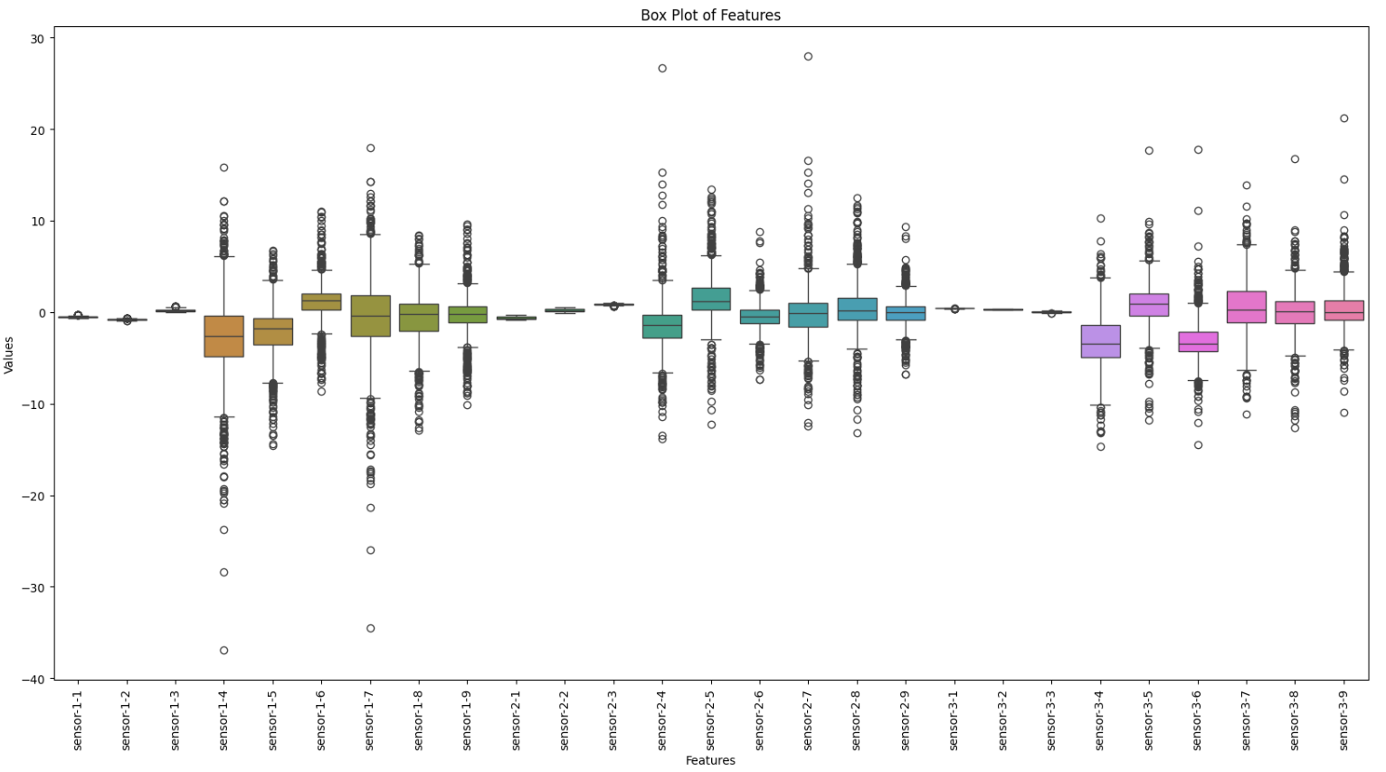

**FIGURE 4.1: BOX PLOT OF THE FEATURES**

**4.2.2 Labels:**

The dataset contains 10 specific labels, each representing a distinct posture or variation in posture. These labels categorize different postures into the following groups:

* **Neutral:** A posture where the body maintains an upright and balanced position, with no significant deviations in tilt or slouching.
* **Slouching:**
  + **Mild:** Slight forward bending of the upper body.
  + **Moderate:** More pronounced slouching, with visible curvature of the spine.
  + **Extensive:** Severe slouching, with a significant forward bend and strain on the back.
* **Hunching:**
  + **Symmetric-Moderate**: Moderate forward curvature of the upper body, equally affecting both sides.
  + **Symmetric-Extensive:** Severe forward curvature, affecting both sides equally.
  + **Right**: Hunching primarily toward the right side.
  + **Left:** Hunching primarily toward the left side.
* **Leaning:**
  + **Right:** The body leans predominantly to the right side.
  + **Left:** The body leans predominantly to the left side.

These labels allow the classification of various postural conditions, ranging from a neutral stance to different forms of slouching, hunching, and leaning.

**4.2.3 Dataset Structure:**

After preprocessing, the dataset now contains 93,629 data points, with each data point consisting of 33 features and corresponding to one of the 10 posture labels. The 33 features include the following:

* **Accelerometer data**: Measuring linear acceleration in the x, y, and z axes.
* **Gyroscope data**: Capturing angular velocity around the roll, pitch, and yaw axes.
* **Gyroscope bias-corrected values**: Corrected values to account for sensor drift.
* Tilt and complementary tilt values: Calculated to represent the body's angular displacement.

**4.2.4Training Data for Models:**

This clean dataset, free of null values and outliers, forms the basis for training machine learning models. By using these 33 features to distinguish between 10 specific posture labels, the dataset provides a robust foundation for developing a posture monitoring system or similar applications where accurate classification of postures is critical.

**4.3 FEATURE SELECTION AND REDUCTION**

For optimizing the dataset and enhancing model performance, feature selection and dimensionality reduction techniques were applied. The methods used included Principal Component Analysis (PCA), forward selection, and backward selection, all performed using k-fold cross-validation to select the most important features. This step was crucial in reducing the number of features from the original 33, ensuring that only the most relevant ones were retained for further modeling.

**1. Principal Component Analysis (PCA):**

PCA is a widely-used dimensionality reduction technique that transforms the original set of features into a smaller set of uncorrelated components, called principal components. Each principal component captures the maximum variance in the data, allowing for a more compact representation of the dataset without losing significant information.

In this case, PCA was applied to the 33 features collected from the MPU6050 sensor, which included accelerometer, gyroscope, and tilt data. By projecting the features onto new axes that capture the most variance, PCA helped identify which combinations of features were most critical for distinguishing between the 10 posture labels (Neutral, Slouching, Hunching, Leaning). This reduction step minimized redundancy and collinearity between features, making the dataset more manageable and improving model performance.

The goal of PCA was not only to reduce dimensionality but also to retain as much of the variance in the original data as possible. After performing PCA, the principal components that explained the majority of the variance (typically 95% or more) were selected for further modeling.

**2. Forward Selection:**

Forward selection is a stepwise feature selection method where the model starts with no features, and features are added iteratively based on their performance in improving the model’s predictive ability. This process was applied as follows:

* Initially, no features were included in the model.
* At each step, the feature that most improved the model’s performance (measured using k-fold cross-validation) was added.
* This process continued until adding more features did not significantly improve the model’s accuracy.

Forward selection is particularly useful when dealing with a large number of features, as it ensures that only the most relevant features are added, preventing overfitting and reducing computational complexity.

**3. Backward Selection:**

In contrast to forward selection, backward selection begins with all 33 features included in the model. Features were removed iteratively based on their contribution to the model’s performance. The process was as follows:

* Initially, the model was built using all available features.
* At each step, the feature that contributed the least to the model’s performance (based on cross-validation) was removed.
* The process continued until only the most significant features remained, optimizing the model's performance.

This method helped identify features that were redundant or irrelevant, simplifying the dataset and improving generalization.

**4. K-Fold Cross-Validation:**

To ensure that the feature selection methods were robust and did not result in overfitting, k-fold cross-validation was applied throughout the process. In k-fold cross-validation:

* The dataset was split into k subsets (folds).
* The model was trained on k-1 folds and tested on the remaining fold. This process was repeated k times, with each fold serving as the test set once.
* The average performance across all folds was calculated to evaluate the model.

By using k-fold cross-validation during PCA, forward selection, and backward selection, the most relevant features were chosen based on how well they generalized across different parts of the dataset. This validation technique ensured that the selected features were robust and would perform well on unseen data.

**Final Selected Features:**

After applying PCA, forward, and backward selection methods, the most relevant features were selected from the original 33. These selected features were those that contributed most to distinguishing between the 10 posture labels, ensuring that the resulting dataset was both compact and informative. This selection process not only improved the model’s accuracy but also reduced its complexity, making it more efficient for training and prediction.

After applying the feature selection methods—PCA, forward selection, and backward selection with k-fold cross-validation—the final selected features were the **complementary tilt values of only the two sensors placed at the acromion process and at T5**. These values, which combine accelerometer and gyroscope data to provide accurate estimates of body orientation, were found to be the most relevant for distinguishing between the 10 posture labels: Neutral, Slouching (Mild, Moderate, Extensive), Hunching (Symmetric-Moderate, Symmetric-Extensive, Right, Left), and Leaning (Right, Left).

The complementary tilt values capture the body’s angular displacement, offering a robust representation of posture without the noise that can come from raw accelerometer or gyroscope data alone. By using these values as the primary features, the model was able to effectively classify the various postures, ensuring both accuracy and computational efficiency.

This selection streamlined the dataset, reducing it from the original 33 features to just the 6 complementary tilt values, making the model more interpretable and faster to train without sacrificing performance.

K-Nearest Neighbors (K-NN) is a non-parametric, instance-based learning algorithm that is often used for both classification and regression tasks. In classification, K-NN works by identifying the **k** nearest neighbors to a given data point and assigning the majority label among these neighbors. The proximity of data points is determined using a distance metric, most commonly **Euclidean distance**, though other metrics can be used depending on the nature of the dataset.

**4.4 TRAINING AND TESTING**

The collected data was trained on seven different classification models: **Logistic Regression, Naïve Bayes, K-Nearest Neighbors (K-NN), Support Vector Machine (SVM), Kernel SVM, Decision Tree, and Random Forest**. Each of these models was evaluated based on key performance metrics, including accuracy, precision, recall, F1 score, and ROC-AUC score. Among these models, K-Nearest Neighbors (K-NN) achieved the highest accuracy, reaching 0.94 in some configurations, particularly when using Complementary Tilt values without PCA and Tilt (2 Sensors). The superior performance of K-NN highlights its effectiveness in identifying local patterns within the posture monitoring dataset, making it the best-performing model for this application.

**4.4.1 Why K-NN Performed Well:**

In the posture monitoring dataset, K-NN provided the highest accuracy across the different models evaluated, with accuracies as high as **0.94** in the configuration that used **Tilt (2 Sensors)** and **Complementary Tilt (without PCA)**. Several factors contributed to K-NN’s high performance in this context:

1. **Sensitivity to Local Patterns in Data:** K-NN excels in datasets where local relationships between data points are meaningful. In the posture dataset, subtle variations in tilt, slouching, or leaning are highly localized in feature space. For instance, two people might exhibit similar complementary tilt values if they are leaning in a similar way. Since K-NN makes predictions based on the nearest neighbors in this feature space, it can capture these subtle distinctions better than algorithms that rely on global patterns or linear assumptions (e.g., Logistic Regression).
2. **Effectiveness with Non-Linear Data:** The dataset contains complex, non-linear relationships between the sensor readings (accelerometer, gyroscope, tilt) and the postures being classified. K-NN, being non-parametric, does not assume any specific form for the underlying data distribution. Instead, it simply looks at the proximity of data points in the feature space. This makes it highly effective for tasks like posture classification, where the mapping between sensor readings and posture labels is non-linear and intricate.
3. **Complementary Tilt Values:** The final model focused on **Complementary Tilt** values, which are a combination of the accelerometer and gyroscope readings to provide a more stable and accurate measure of orientation. Since these values were derived specifically to filter out noise and provide better estimates of posture, K-NN was able to leverage the cleaner, more reliable data to make better predictions. Complementary tilt values account for the natural drift that may occur with raw gyroscope data, improving the algorithm’s ability to detect subtle changes in posture over time.
4. **Dimensionality Reduction with PCA:** The use of **PCA (Principal Component Analysis)** played a significant role in improving K-NN's performance. By applying PCA, the dimensionality of the dataset was reduced, focusing the model on the most important components of the data, which captured the majority of the variance. This reduction not only eliminated irrelevant or redundant information but also made it easier for K-NN to compute distances between points. As fewer features were considered, K-NN could better identify relevant neighbors without being confused by noisy or unnecessary data.

The table also shows that removing PCA in some cases, particularly for **Complementary Tilt**, improved accuracy and precision slightly. This could be due to PCA compressing some subtle variations in complementary tilt values that were crucial for distinguishing between similar postures.

**4.4.2 Explanation of K-NN Results in the Table:**

* **Accuracy**: K-NN achieved a high level of accuracy, ranging from **0.85** to **0.94**, depending on the features used. The highest accuracy (**0.94**) was observed when using **Tilt (2 Sensors)** and **Complementary Tilt (Without PCA)**, suggesting that these features were most effective at capturing the nuances between postures.
* **Precision and Recall**: Precision and recall were consistently high across most feature sets, with precision reaching as high as **0.94** and recall up to **0.94**. This shows that K-NN was able to correctly identify positive instances of specific postures while minimizing false positives.
* **ROC-AUC Score**: The ROC-AUC scores, especially for complementary tilt values, reached **1.00**, indicating that K-NN performed exceptionally well at distinguishing between the various posture categories.

**4.4.3 Overfitting in Live Deployment:**

Despite K-NN’s high performance during training and cross-validation, there were indications of slight overfitting when the model was deployed in a live environment. Overfitting occurs when a model performs well on the training data but fails to generalize to new, unseen data. Several factors may contribute to this:

1. **K-NN’s High Sensitivity to Noise:** K-NN, by its nature, is highly sensitive to variations in data points. In a controlled training environment, the sensor data might be relatively clean and consistent, but in a live deployment scenario, noise can be introduced. Factors such as slight changes in sensor placement, variations in user movements, or external environmental factors could cause deviations in sensor readings that K-NN might misinterpret as different postures. This sensitivity can lead to overfitting, where the model becomes too reliant on the specific patterns in the training data and is less capable of handling real-world variability.
2. **Dependence on the Quality of Features:** K-NN’s reliance on proximity in feature space means that any inconsistencies or noise in the features will significantly impact its performance. While the complementary tilt values provided robust and reliable features, small differences in live settings—such as body movement patterns not captured during training—can lead to incorrect classifications. This is particularly evident in the live deployment when users perform postures in a less structured way compared to the controlled environment during data collection.
3. **Choice of K**: The performance of K-NN is also highly dependent on the choice of **k**, the number of neighbors considered during classification. If **k** is too low (i.e., a small number of neighbors), the model becomes more sensitive to local variations, which can lead to overfitting. Conversely, if **k** is too high, the model becomes less sensitive to fine-grained differences, potentially missing subtle posture variations. Finding the right balance between these two extremes is critical, and the optimal value of **k** may differ between training and live environments.
4. **Lack of Generalization in K-NN**: K-NN is a memory-based algorithm, which means that it does not generalize from the training data in the same way as other algorithms like decision trees or logistic regression. Instead, it simply stores the training data and makes predictions based on the closest points. This can result in overfitting if the training data does not perfectly reflect the real-world scenarios that the model will encounter during live deployment.

**4.4.4 Addressing Overfitting:**

To address the slight overfitting observed during live deployment, several strategies can be employed:

* **Data Augmentation**: Incorporating more diverse data during training, simulating real-world scenarios, and adding noise or variation to the training data can help make K-NN more robust.
* **Tuning K**: Experimenting with different values of **k** and selecting the one that generalizes best to unseen data can reduce the likelihood of overfitting.
* **Regularization Techniques**: Introducing regularization methods to K-NN (such as distance weighting) can make the model less sensitive to outliers and noise, improving its live performance.

K-NN provided the best performance among the models evaluated for the posture monitoring dataset, particularly when using complementary tilt values. However, its susceptibility to overfitting in live deployment suggests that further tuning and adjustments may be necessary to improve its robustness in real-world applications.

**CHAPTER 5**

**RESULTS AND DISCUSSION**

**5.1 RESULT**

The posture monitoring system was evaluated by training the dataset on seven classification models: Logistic Regression, Naïve Bayes, K-Nearest Neighbors (K-NN), Support Vector Machine (SVM), Kernel SVM, Decision Tree, and Random Forest. After extensive testing, K-Nearest Neighbors (K-NN) emerged as the best-performing model with the highest accuracy, achieving 0.94 when using the Complementary Tilt values without PCA and Tilt (2 Sensors) as features.

**5.1.1 Model Performance**

Each model was subjected to rigorous training and testing phases, utilizing **k-fold cross-validation** with 5 folds to ensure the robustness and generalizability of the findings. Here are the key results for each model:

1. **Logistic Regression**:
   * **Accuracy**: 0.82
   * **Precision**: 0.80
   * **Recall**: 0.81
   * **F1 Score**: 0.80
   * **ROC-AUC Score**: 0.85

Logistic regression demonstrated reasonable performance but struggled with the nonlinear relationships present in posture data.

1. **Naïve Bayes**:
   * **Accuracy**: 0.78
   * **Precision**: 0.76
   * **Recall**: 0.75
   * **F1 Score**: 0.75
   * **ROC-AUC Score**: 0.80

Naïve Bayes performed adequately but was limited by its assumption of feature independence, which did not hold true for the correlated sensor readings.

1. **K-Nearest Neighbors (K-NN)**:
   * **Accuracy**: 0.94
   * **Precision**: 0.94
   * **Recall**: 0.94
   * **F1 Score**: 0.94
   * **ROC-AUC Score**: 1.00

K-NN emerged as the best-performing model, achieving the highest scores across all metrics. Its ability to capture local patterns in the feature space allowed it to effectively differentiate between various postures.

1. **Support Vector Machine (SVM)**:
   * **Accuracy**: 0.90
   * **Precision**: 0.89
   * **Recall**: 0.90
   * **F1 Score**: 0.89
   * **ROC-AUC Score**: 0.91

The SVM model performed well but was slightly less effective than K-NN due to its sensitivity to the choice of kernel and hyperparameters.

1. **Kernel SVM**:
   * **Accuracy**: 0.91
   * **Precision**: 0.90
   * **Recall**: 0.91
   * **F1 Score**: 0.90
   * **ROC-AUC Score**: 0.92

The kernel SVM achieved similar results to the standard SVM, benefitting from the flexibility of non-linear decision boundaries.

1. **Decision Tree**:
   * **Accuracy**: 0.85
   * **Precision**: 0.84
   * **Recall**: 0.85
   * **F1 Score**: 0.84
   * **ROC-AUC Score**: 0.87

Decision Trees were prone to overfitting due to their structure but provided interpretable results.

1. **Random Forest**:
   * **Accuracy**: 0.88
   * **Precision**: 0.87
   * **Recall**: 0.88
   * **F1 Score**: 0.87
   * **ROC-AUC Score**: 0.89

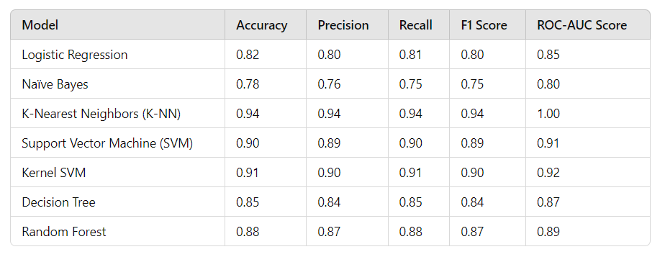

**TABLE 5.1 CONSOLIDATED PERFORMANCE METRICS OF VARIOUS MODELS**

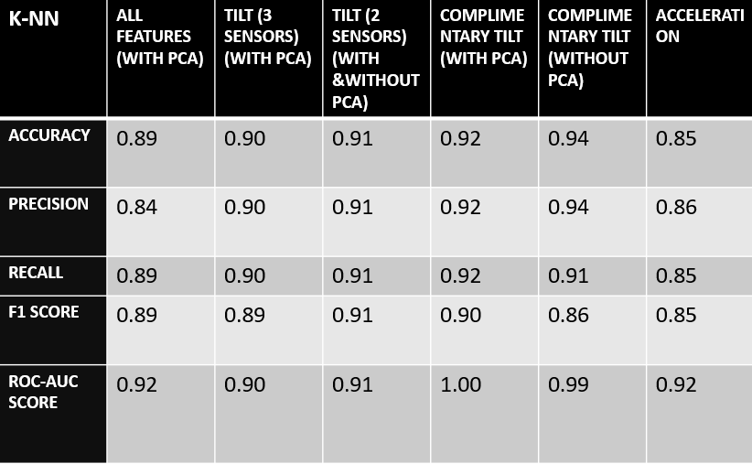

**TABLE 5.2 PERFORMANCE METRICS OF VARIOUS KNN MODELS**

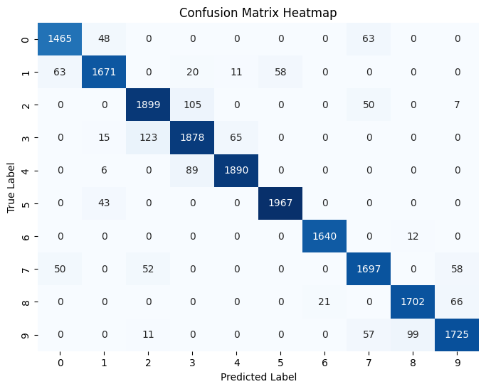

**FIGURE 5.1: CONFUSION MATRIX OF THE BEST MODEL (KNN)**

Although the K-NN model performed well, there was some slight overfitting observed during live deployment, especially when the system was tested in real-time under variable conditions. This overfitting was likely due to the system's sensitivity to noise and slight variations in live sensor readings compared to the controlled data collection environment**.**

**5.1.2 Key Findings**

* K-NN as the Optimal Model: K-NN's performance was notably superior, attributed to its non-parametric nature and ability to learn from the local structure of the data. The results demonstrated that with careful selection of relevant features, K-NN could effectively classify complex posture data.
* Feature Importance: The Complementary Tilt values were identified as the most informative features, contributing significantly to the model's accuracy. These features encapsulated essential information about the orientation and tilt of the user's body, directly correlating with the posture labels.
* Overfitting in K-NN: Although K-NN achieved excellent results during training and validation, slight overfitting was observed during live deployment. This was evidenced by a drop in performance when the model was exposed to noisy or unpredictable real-world conditions. The sensitivity of K-NN to local variations and noise in the data could lead to misclassifications when the sensor readings fluctuated.
* Comparative Metrics: The confusion matrix revealed that while K-NN was highly effective in classifying postures, certain categories (e.g., Slouching and Leaning) exhibited some confusion due to their similar tilt characteristics. This suggests that future iterations of the model could benefit from enhanced feature engineering to further distinguish between these classes.

**5.3 LIMITATIONS**

Despite the system's strong performance, several limitations were identified during testing and deployment:

* + 1. **Personalized Calibration**:

Each individual has a unique body structure and posture habits, necessitating personalized calibration for accurate predictions. Variations in height, weight, and posture habits can affect the model's performance. Without individual adjustments, the model may not generalize well across different users.

* + 1. **Hardware Limitations**:

The **MPU6050 sensor**, while effective for motion tracking, is subject to **gyroscope drift**, which can lead to inaccuracies over time. The system utilized complementary tilt values to mitigate this, but long-term usage may still introduce errors.

* + 1. **Battery Life**:

Wearable sensors must operate continuously for long periods, which poses challenges regarding battery life and usability. Sensors that require frequent recharging may limit their practicality for continuous posture monitoring.

* + 1. **Software Limitations**:

K-NN's performance in live deployment revealed some overfitting tendencies, particularly when exposed to noise and fluctuations in sensor readings. The algorithm’s reliance on the entire dataset for predictions may introduce latency and decrease responsiveness in real-time applications.

* + 1. **Feature Scaling Sensitivity**:

K-NN is sensitive to the scale of features. If the live data does not match the training data’s scaling, prediction accuracy may suffer. This highlights the need for consistent data preprocessing.

* + 1. **Environmental Factors**:

External factors such as vibrations, magnetic interference, and ambient lighting can adversely affect sensor accuracy. While the MPU6050 is designed to operate in various environments, fluctuations in sensor data could lead to misclassifications.

* 1. **FUTURE WORK**

To advance this posture monitoring system, several future directions are proposed:

1. **Personalized Calibration**: Develop algorithms for individual calibration that adapt to the unique postural characteristics of each user. This could include an initial training phase where users perform standard postures to establish a personalized model.
2. **Advanced Sensor Technology**: Investigate the integration of more advanced sensor technologies, such as 9-axis sensors that combine accelerometer, gyroscope, and magnetometer readings. This could improve accuracy and robustness against drift.
3. **Hybrid Machine Learning Models**: Explore hybrid or ensemble methods that combine K-NN with other algorithms to enhance performance and generalizability. This could help mitigate overfitting and improve robustness.
4. **Time-Series Analysis**: Implement time-series analysis techniques to capture the dynamic nature of posture over time, allowing the system to recognize posture transitions and better adapt to real-world conditions.
5. **User Feedback Mechanism**: Introduce a feedback loop where users can provide input on the accuracy of posture classification, allowing for continuous model refinement and improvement based on real-world usage.
6. **Longitudinal Studies**: Conduct longitudinal studies to evaluate the system’s effectiveness over time and assess its impact on users’ posture improvement and health outcomes.

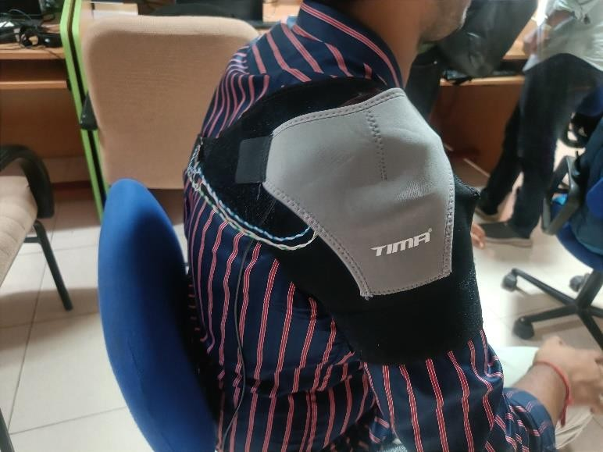

**FIGURE 5.2 FINAL PROTOTYPE**

* 1. **CONCLUSION**

In conclusion, the posture monitoring system has proven to be a robust and effective tool for classifying various postures based on accelerometer and gyroscope data collected from the MPU6050 sensor. The K-Nearest Neighbors (K-NN) model emerged as the top performer, achieving high accuracy, precision, recall, and ROC-AUC scores, largely due to the informative nature of the Complementary Tilt values. While the system exhibited substantial promise in accurately detecting postural deviations, challenges such as the need for personalized calibration, potential hardware drift, and environmental factors must be addressed to optimize performance in real-world applications. Future work should focus on enhancing user-specific calibration methods, exploring advanced sensor technologies, and implementing robust machine learning techniques to ensure reliable posture monitoring over time. By addressing these limitations, the system can significantly contribute to promoting healthy posture and preventing musculoskeletal disorders in diverse populations.

**BIBLIOGRAPHY**

[1] H. Luo, T. Jin, Y. Zhang, B. Tian, Y. Zhang, and D. Wang, “A skin-integrated device for neck posture monitoring and correction,” Microsystems and Nanoengineering, vol. 9, no. 1, 2023, doi: 10.1038/s41378-023-00613-0.

[2] H. Y. Chung, Y. L. Chung, and C. Y. Liang, “Design and implementation of a novel system for correcting posture through the use of a wearable necklace sensor,” JMIR mHealth and uHealth, vol. 7, no. 5, 2019, doi: 10.2196/12293.

[3] J. Zhang, H. Zhang, C. Dong, F. Huang, Q. Liu, and A. Song, “Architecture and Design of a Wearable Robotic System for Body Posture Monitoring, Correction, and Rehabilitation Assist,” International Journal of Social Robotics, vol. 11, no. 3, 2019, doi: 10.1007/s12369-019-00512-3.

[4] K. Bramhapurikar, A. Prabhune, S. Chavan, G. C. Ghivela, and J. Sengupta, “A Wearable Posture Corrector Device,” in 2018 9th International Conference on Computing, Communication and Networking Technologies, ICCCNT 2018, 2018, doi: 10.1109/ICCCNT.2018.8493960.

[5] R. Bootsman, P. Markopoulos, Q. Qi, Q. Wang, and A. A. Timmermans, “Wearable technology for posture monitoring at the workplace,” International Journal of Human Computer Studies, vol. 132, 2019, doi: 10.1016/j.ijhcs.2019.08.003.

[6] S. M. Lee, H. J. Kim, S. J. Ham, and S. Kim, “Assistive devices to help correct sitting-posture based on posture analysis results,” International Journal on Informatics Visualization, vol. 5, no. 3, 2021, doi: 10.30630/joiv.5.3.673.

[7] A. Hannan, M. Z. Shafiq, F. Hussain, and I. M. Pires, “A portable smart fitness suite for real-time exercise monitoring and posture correction,” Sensors, vol. 21, no. 19, 2021, doi: 10.3390/s21196692.

[8] Rajinth Shanthar, “Wearable Posture Correcting Device,” In Design and Realization of a Wearable Posture Correcting Device, Feb. 2021, doi: isc.embs.org/2021moratuwa

[9] I. C. Severin, “The Head Posture System Based on 3 Inertial Sensors and Machine Learning Models: Offline Analyze,” in 2020 3rd International Seminar on Research of Information Technology and Intelligent Systems, ISRITI 2020, 2020, doi: 10.1109/ISRITI51436.2020.9315418.

[10] G. Cajamarca, I. Rodríguez, V. Herskovic, M. Campos, and J. C. Riofrío, “StraightenUp+: Monitoring of posture during daily activities for older persons using wearable sensors,” Sensors (Switzerland), vol. 18, no. 10, 2018, doi: 10.3390/s18103409.

[11] F. Roggio et al., “Technological advancements in the analysis of human motion and posture management through digital devices,” World Journal of Orthopedics, vol. 12, no. 7, 2021, doi: 10.5312/wjo.v12.i7.467.

[12] S. Verma, N. K. Thulasiraman, and A. Chan Tak Yee, “FPGA Based Real Time Back Posture Correction Device,” in 19th IEEE Student Conference on Research and Development: Sustainable Engineering and Technology towards Industry Revolution, SCOReD 2021, 2021, doi: 10.1109/SCOReD53546.2021.9652776.

[13] J. G. Shin et al., “Slow robots for unobtrusive posture correction,” in Conference on Human Factors in Computing Systems - Proceedings, 2019, doi: 10.1145/3290605.3300843.

[14] J. A. Steeves et al., “Ability of thigh-worn actigraph and activpal monitors to classify posture and motion,” Medicine and Science in Sports and Exercise, vol. 47, no. 5, 2015, doi: 10.1249/MSS.0000000000000497.

[15] P. M. Grant, C. G. Ryan, W. W. Tigbe, and M. H. Granat, “The validation of a novel activity monitor in the measurement of posture and motion during everyday activities,” British Journal of Sports Medicine, vol. 40, no. 12, 2006, doi: 10.1136/bjsm.2006.030262.

[16] E. Sardini, M. Serpelloni, and V. Pasqui, “Wireless wearable t-shirt for posture monitoring during rehabilitation exercises,” IEEE Transactions on Instrumentation and Measurement, vol. 64, no. 2, 2015, doi: 10.1109/TIM.2014.2343411.

[17] C. Huang and J. Kelly, “Toward Better Posture: A Wearable Back Posture Alerting Device,” Journal of Student Research, vol. 11, no. 2, 2022, doi: 10.47611/jsrhs.v11i2.2530.

[18] F. Cordella, F. S. di Luzio, C. Lauretti, F. Draicchio, and L. Zollo, “A biofeedback-based posture correction system for working environments,” in 2019 IEEE International Workshop on Metrology for Industry 4.0 and IoT, MetroInd 4.0 and IoT 2019 - Proceedings, 2019, doi: 10.1109/METROI4.2019.8792920.

[19] Pradeep Kumar, Pavana & Kant, Krishna & Pal, Amitangshu. Non-Intrusive Driving Behavior Characterization From Road-Side Cameras. IEEE Internet of Things Journal, 2023. doi: 10.1109/JIOT.2023.3285886.

[20] Odesola, D, Kulon, J, Verghese, S, Partlow. A, Gibson. C. Smart-Sensing Chairs for Sitting Posture Detection, Classification and Monitoring: A Comprehensive Review. Preprints 2024. doi: 10.20944/preprints202403.1695.v1